**Experiment 1**

**AIM**

To perform classification with word vectors.

**Software used**

Jupyter Notebook

**Dataset Used**

BBC-text.csv

**Theory**

A word vector is an attempt to mathematically represent the meaning of a word. In essence, a computer goes through some text (ideally a lot of text) and calculates how often words show up next to each other. These frequencies are represented with numbers. So if the word ‘good’ always shows up next to the word ‘friend’ then part of the word vector for ‘good’ will reflect that connection. A given word will have a vast number of such values, usually in the hundreds and sometimes in the thousands.

Once you have this set of numbers for a word, you can compare the vectors of different words. For example, you could compare the different vectors for the words ‘banana,’ ‘kiwi,’ and ‘raincloud.’ Since the vectors are mathematical objects, you can calculate the numerical similarity of different vectors. And since ‘banana’ and ‘kiwi’ are used in a lot of similar contexts and are not used in the contexts where ‘raincloud’ shows up, their vectors will be closer to each other and farther from the vector for ‘raincloud.’

**Code and OUTPUT**

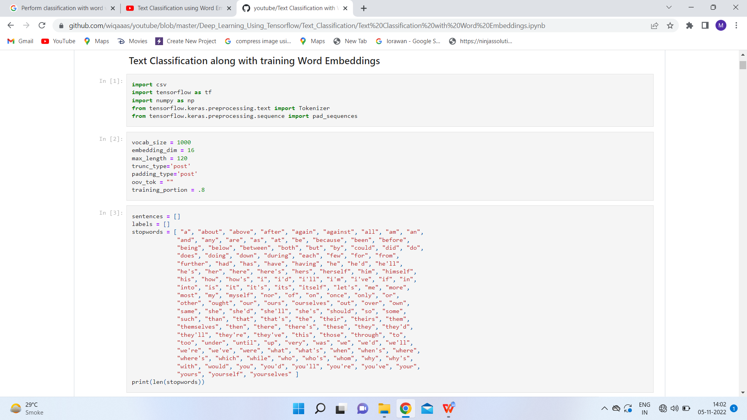

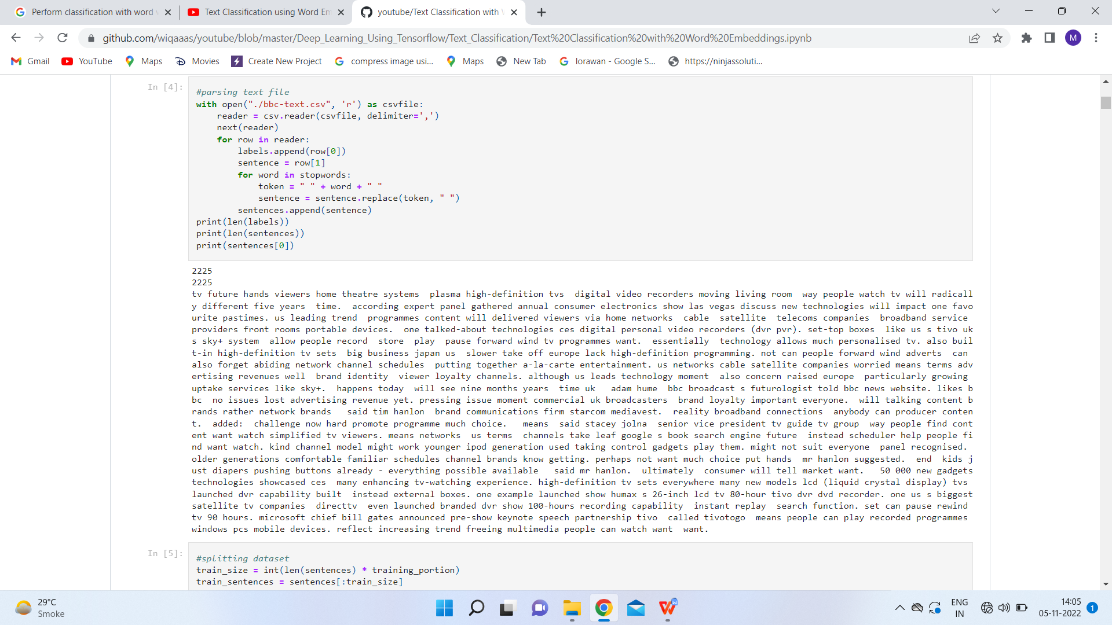

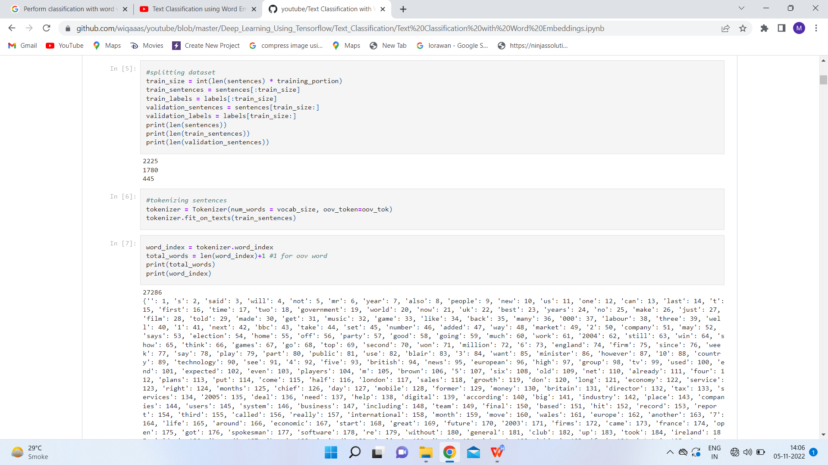

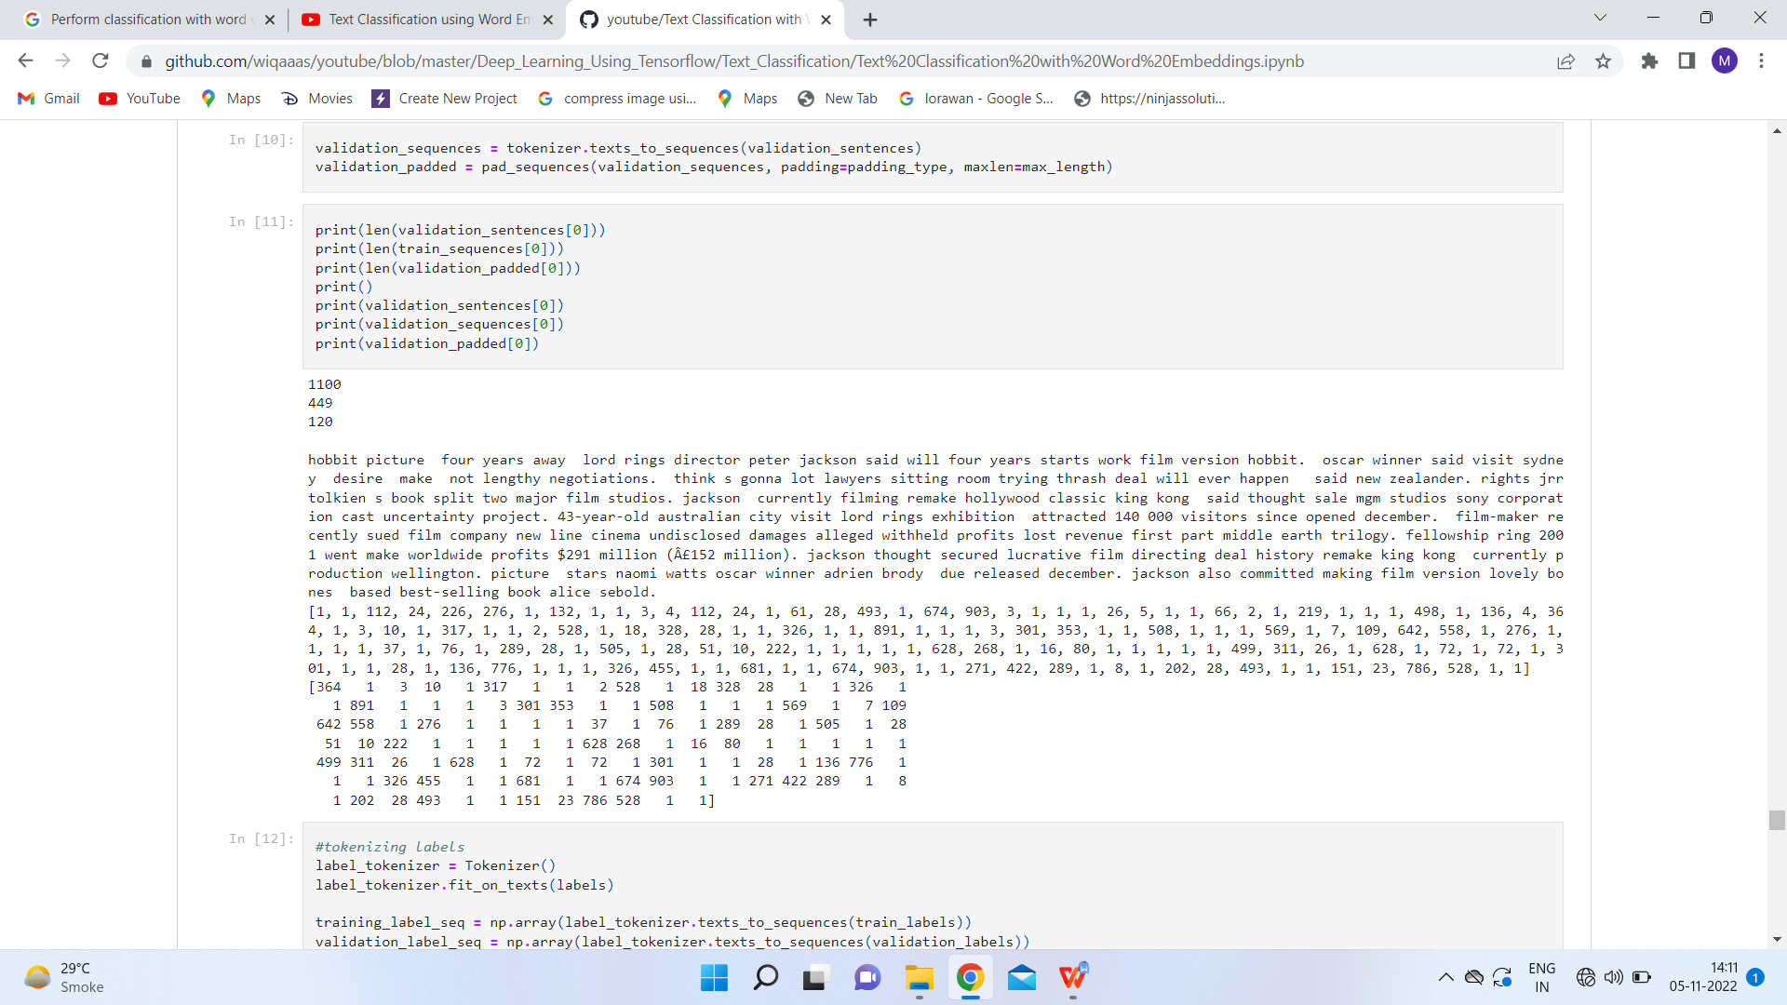

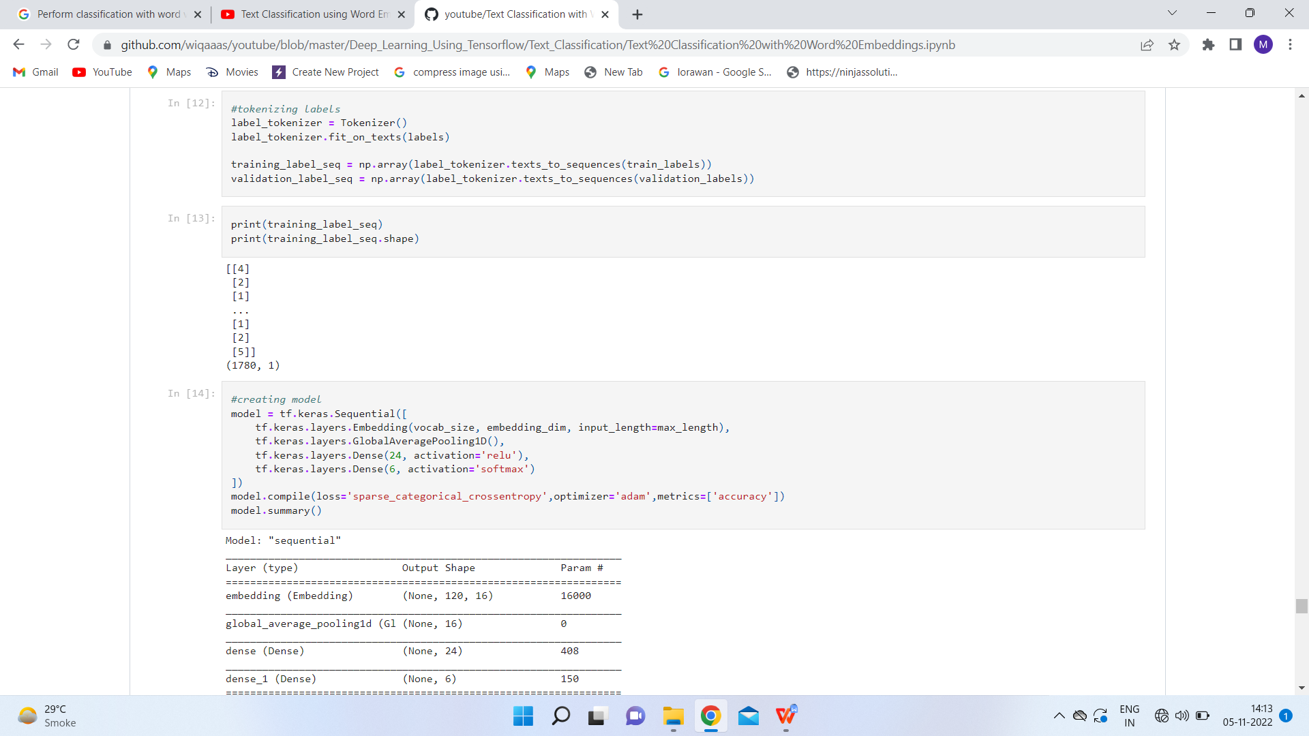

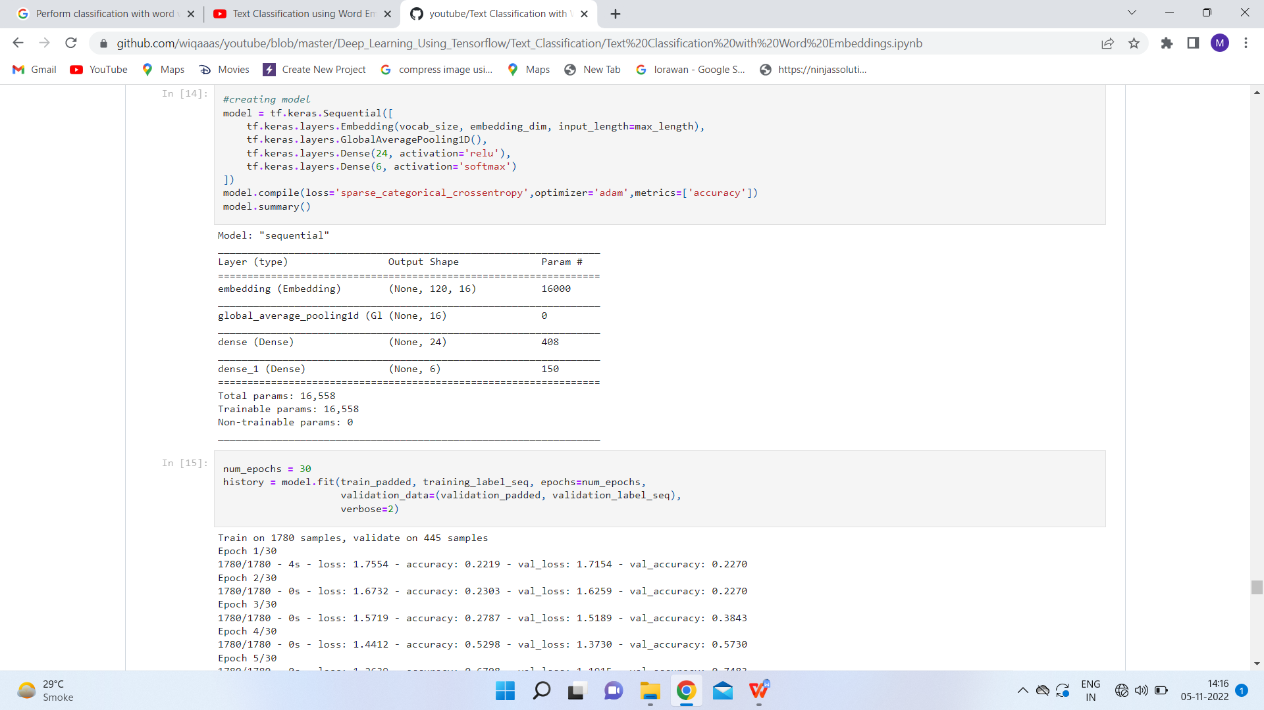

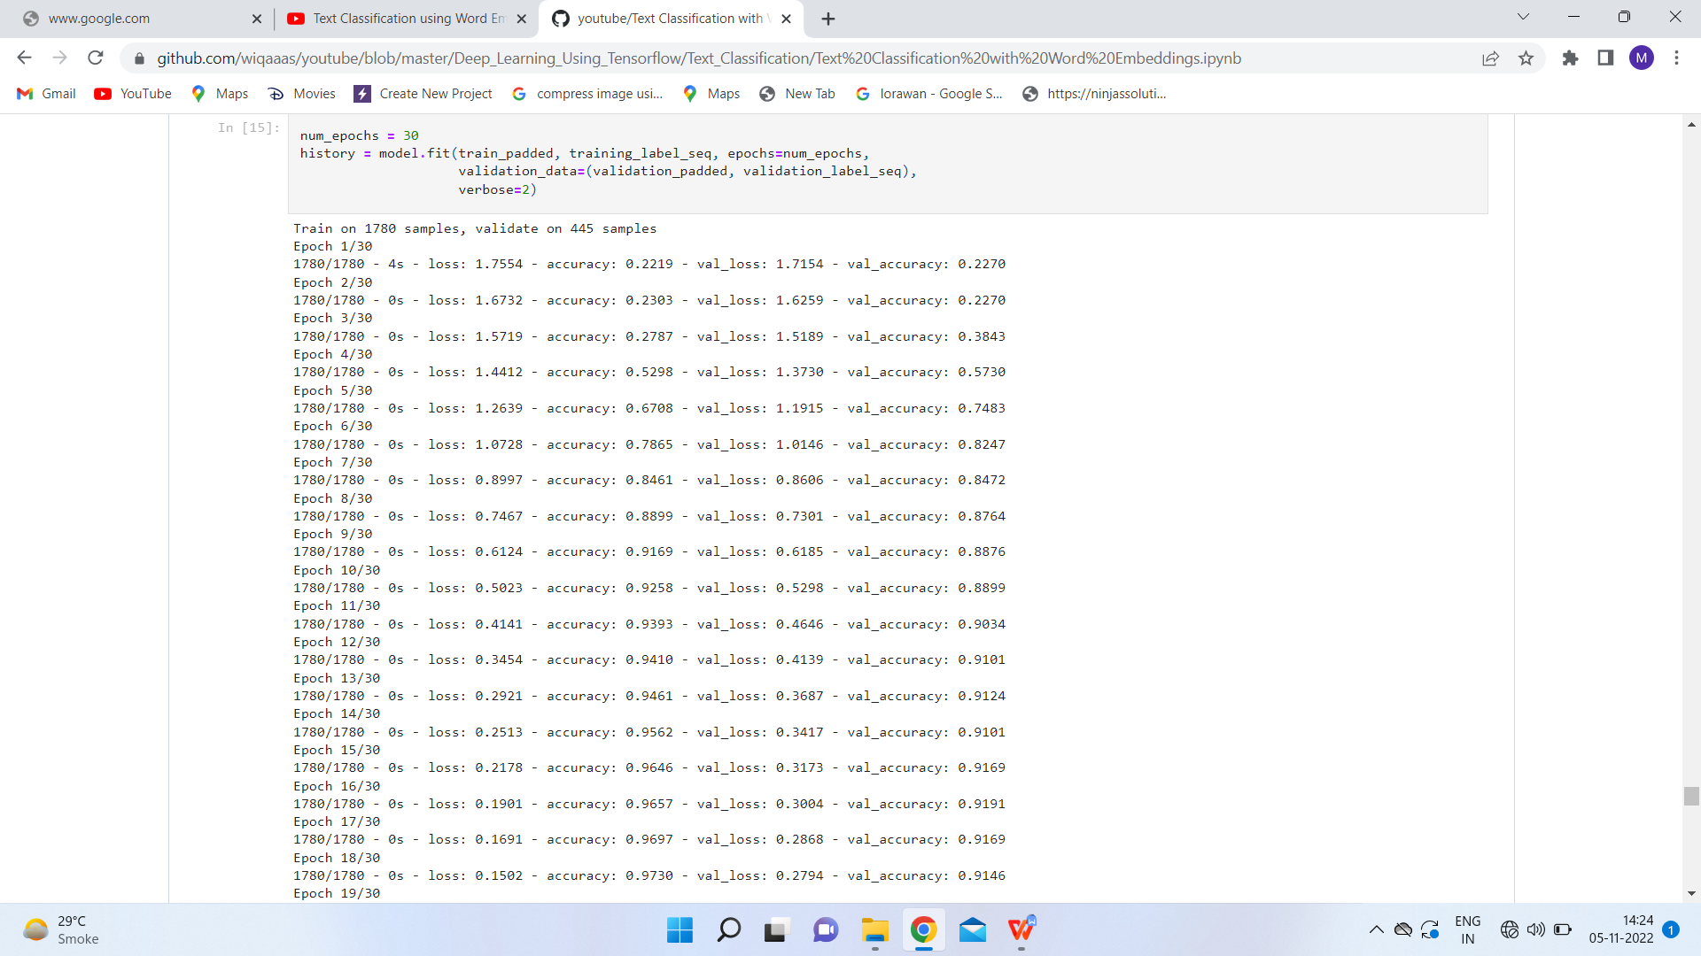

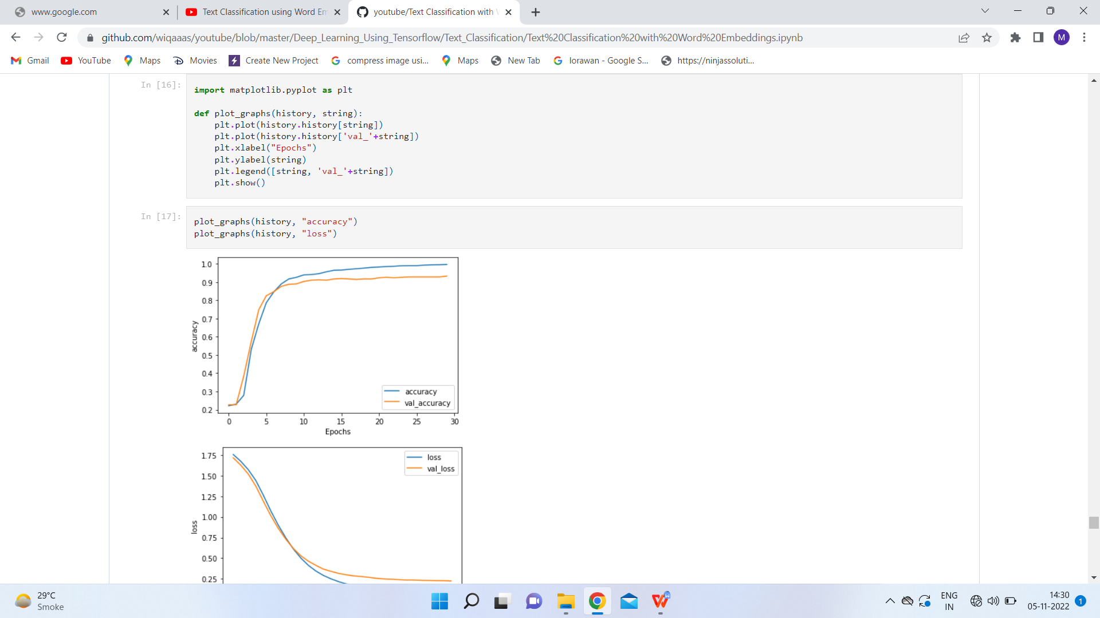

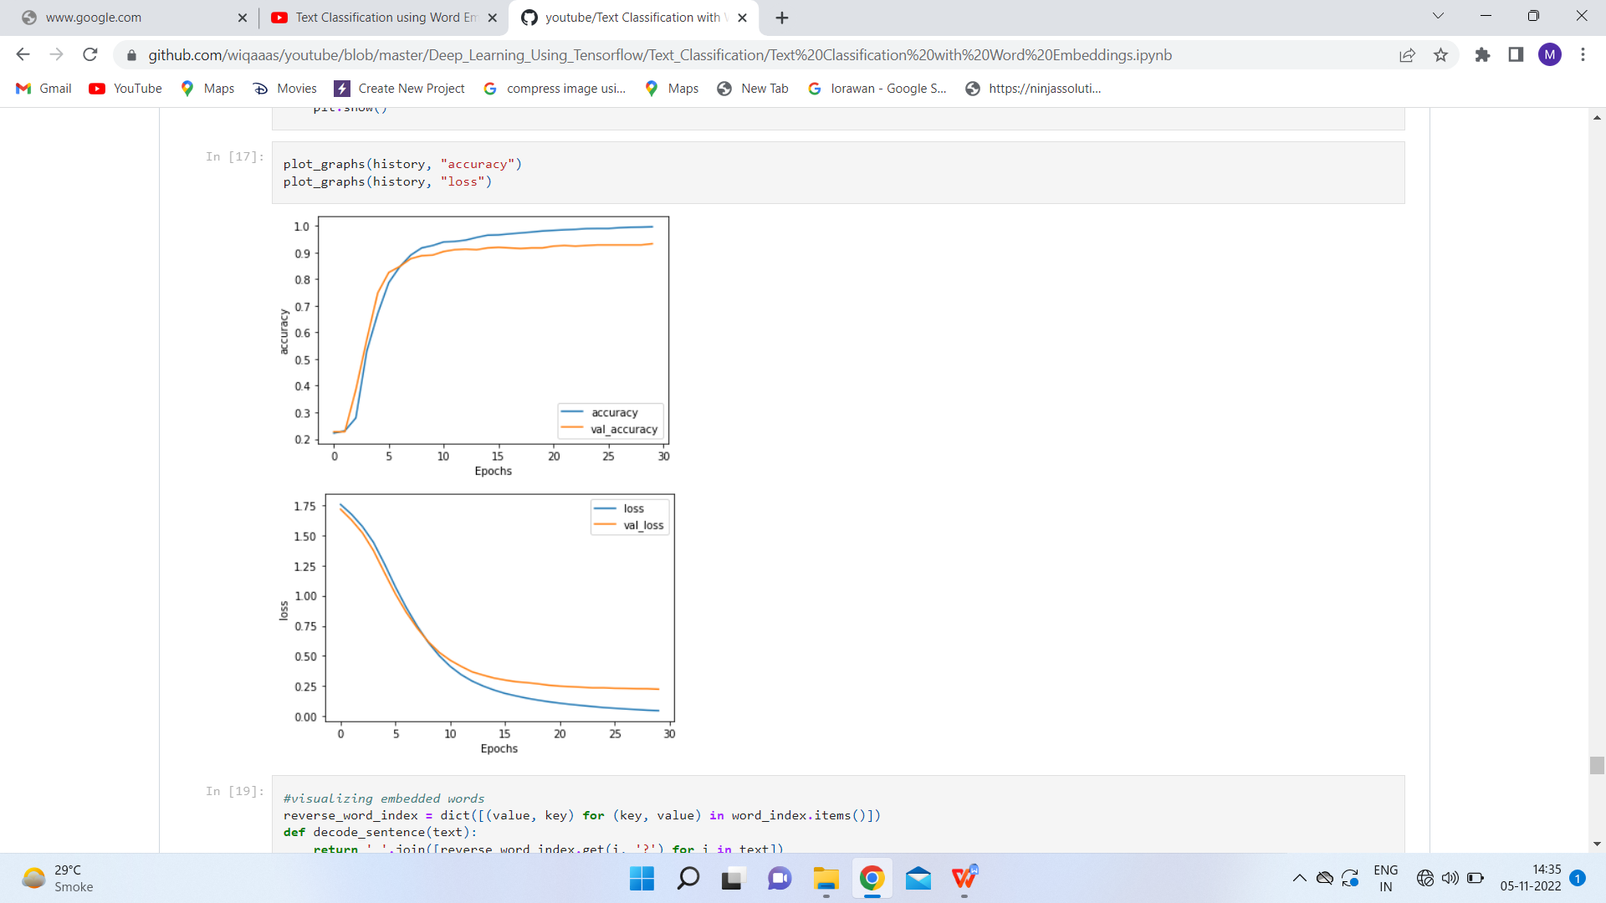

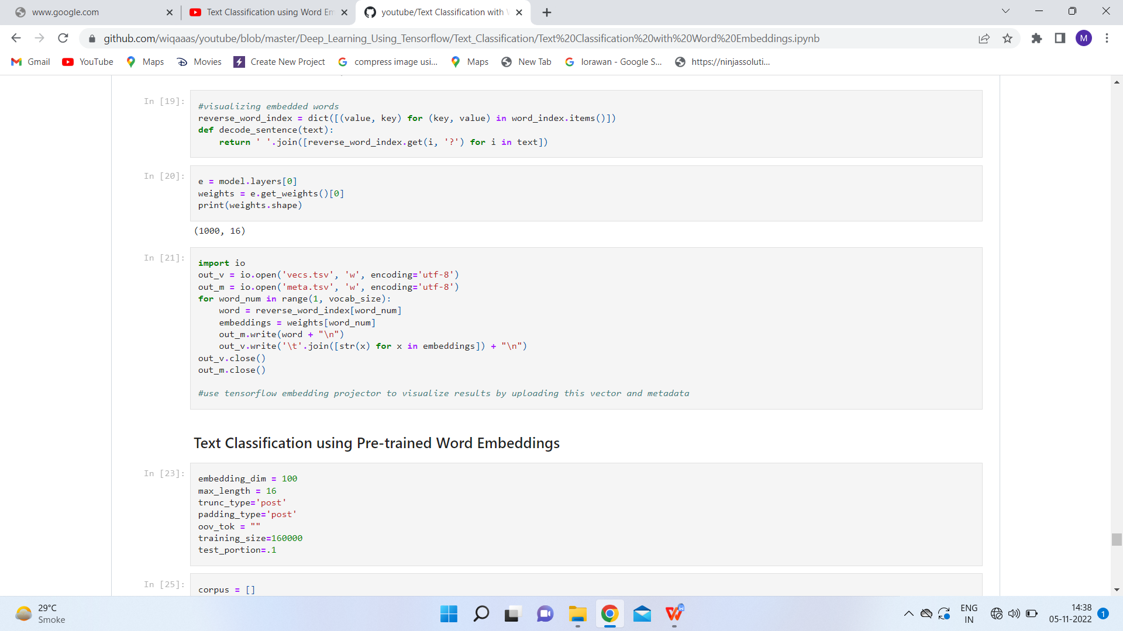

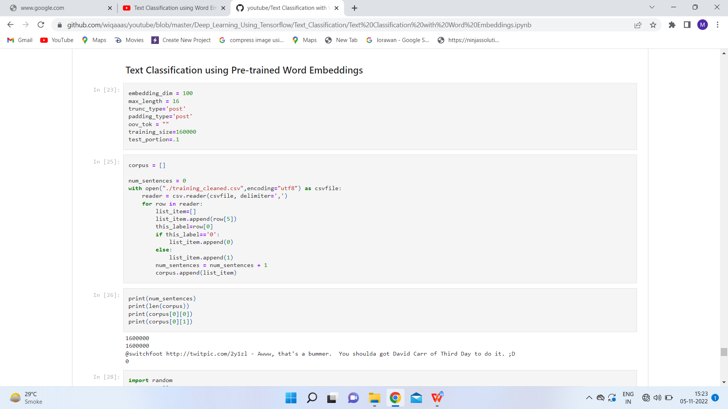

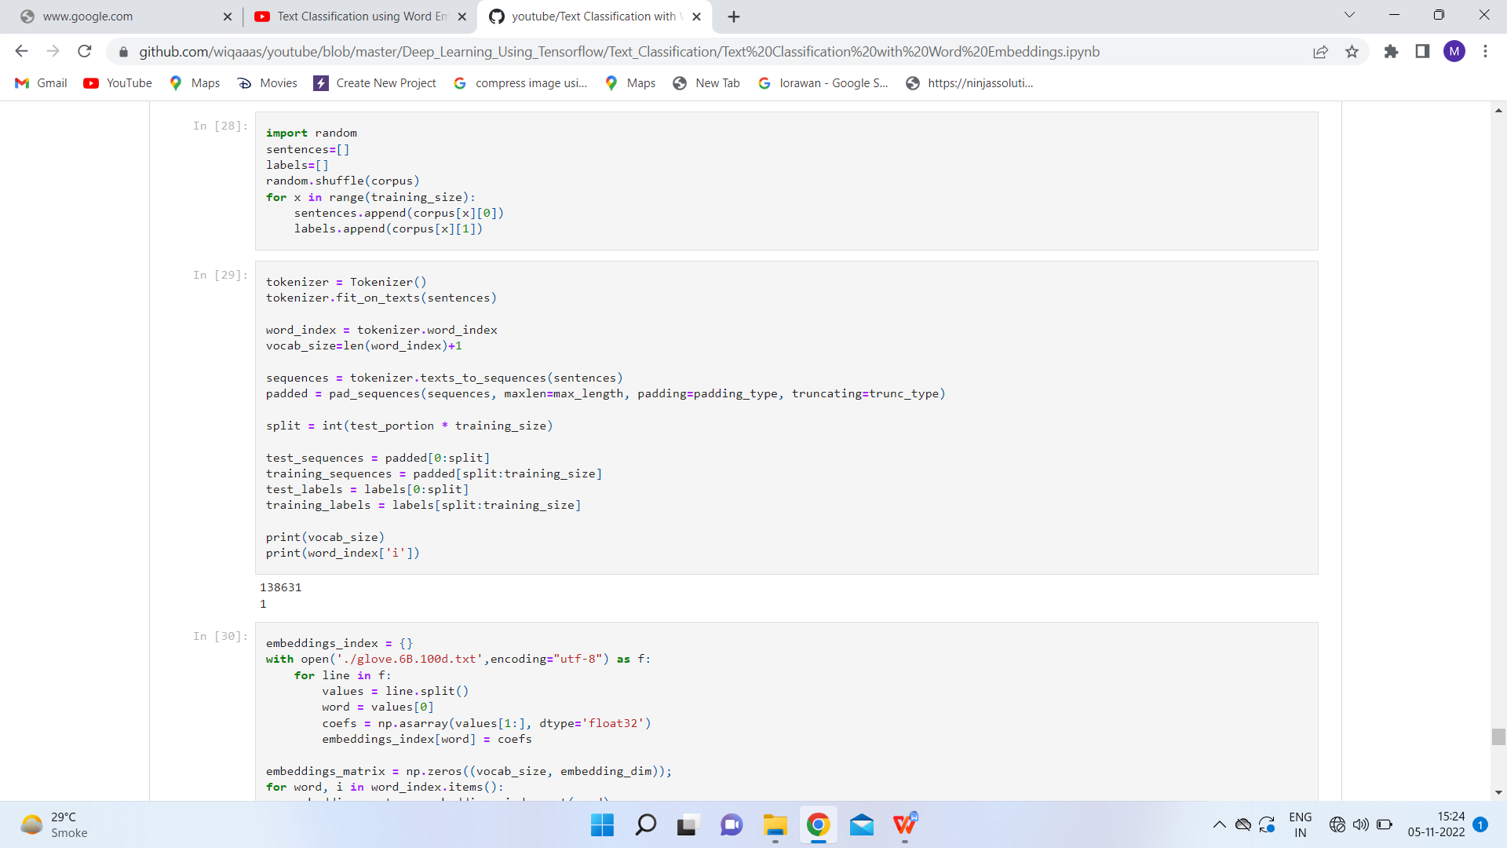

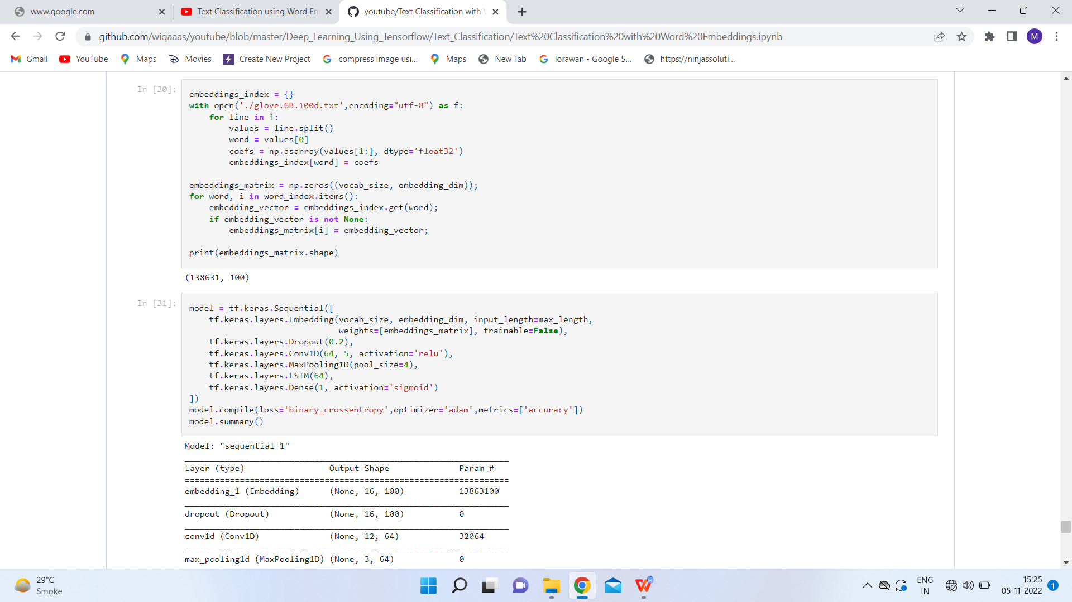

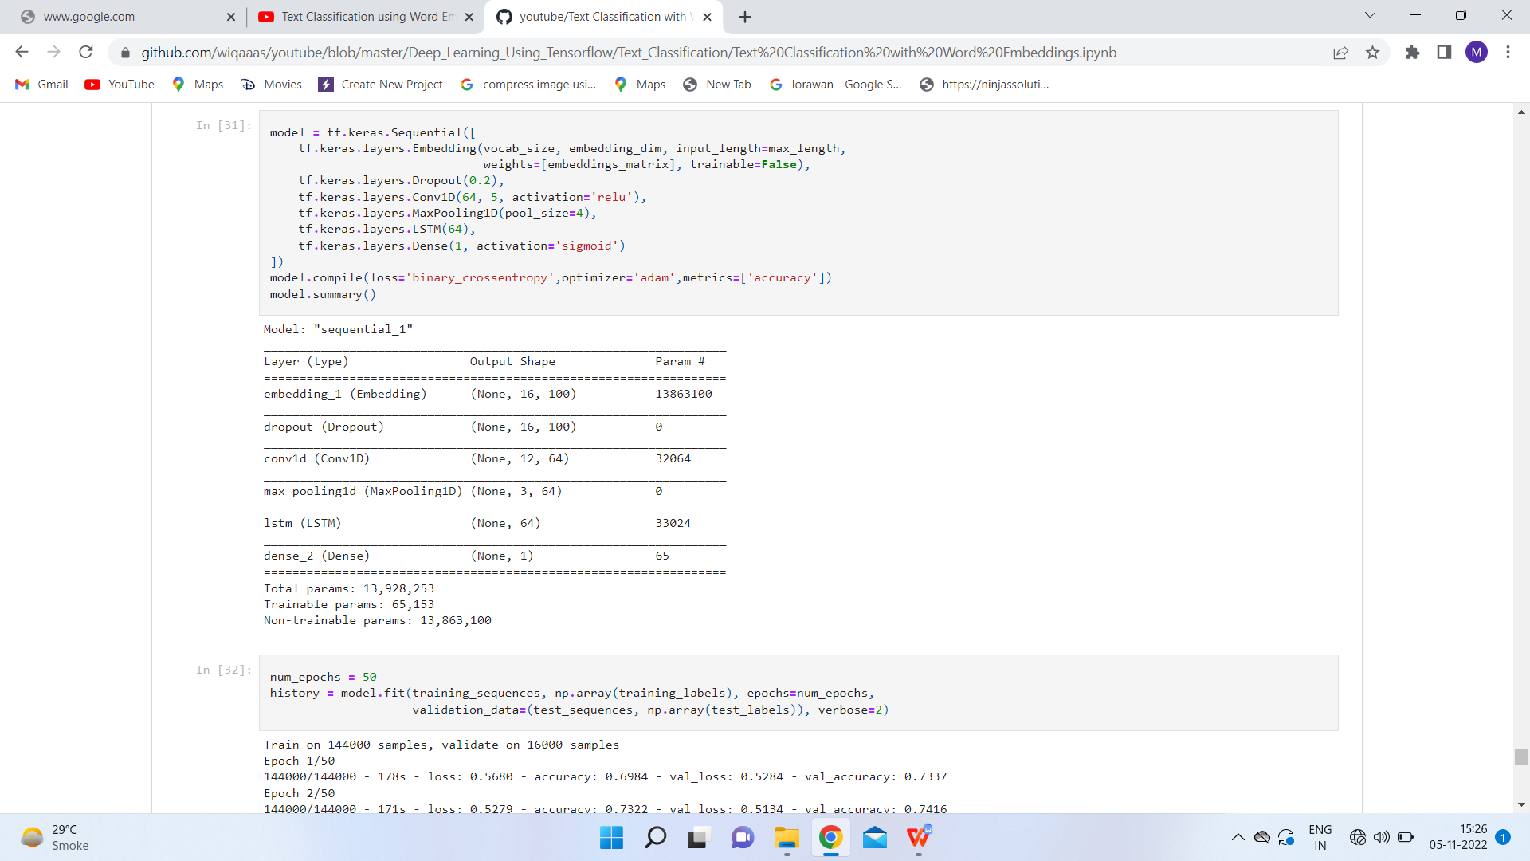

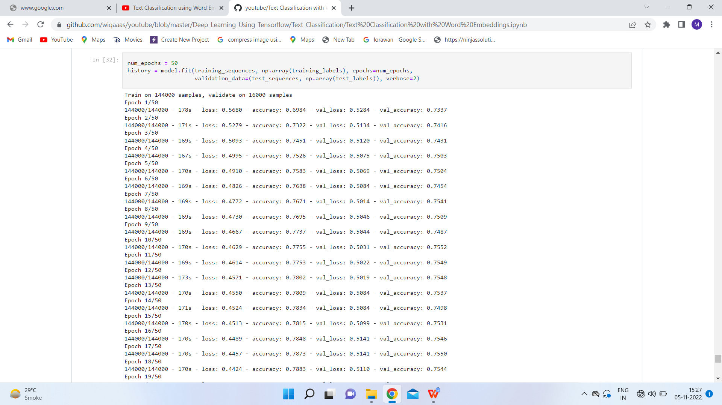

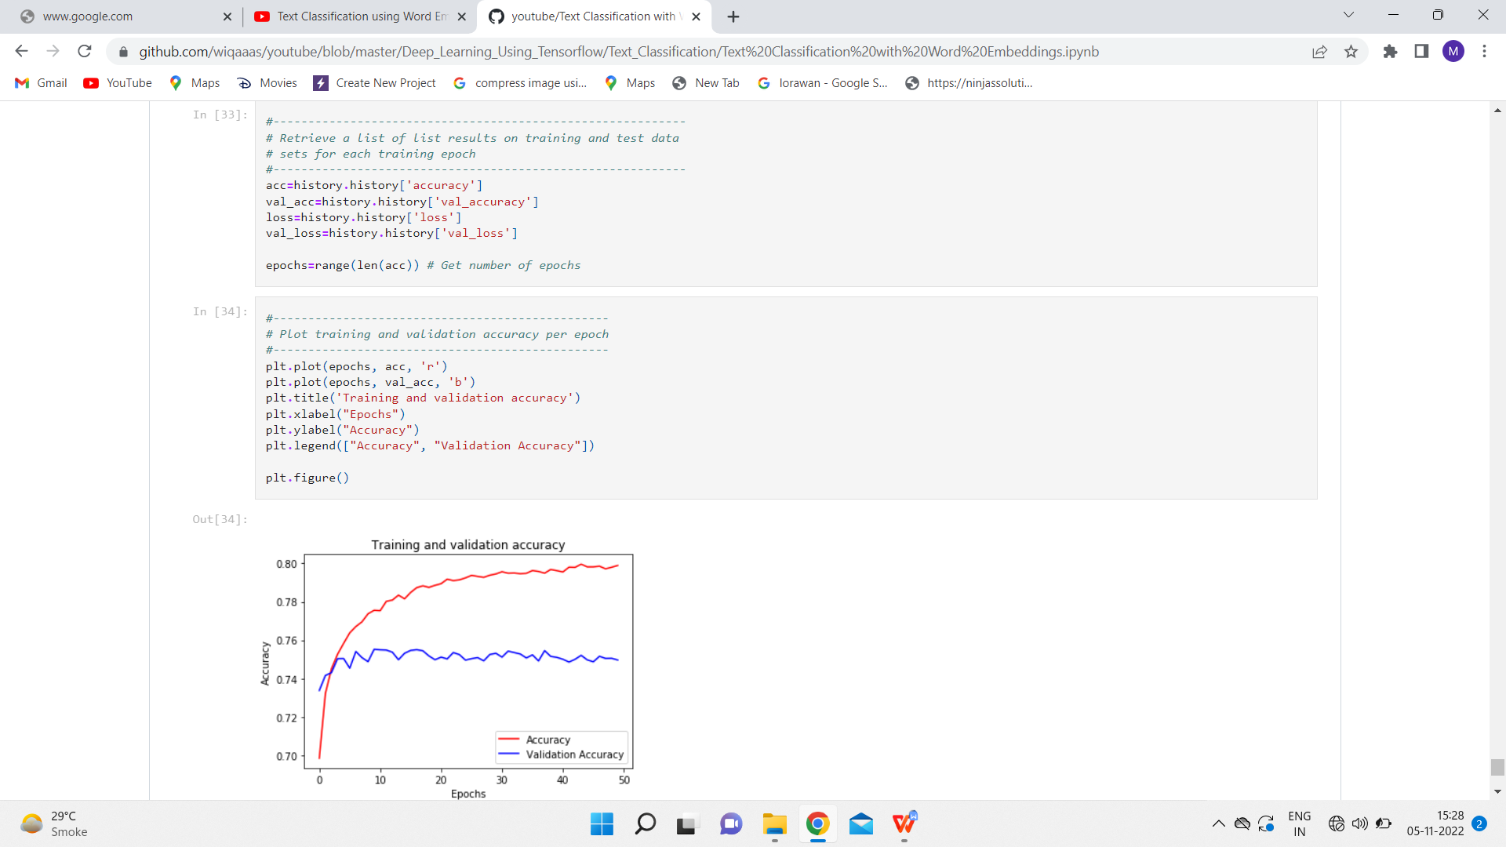

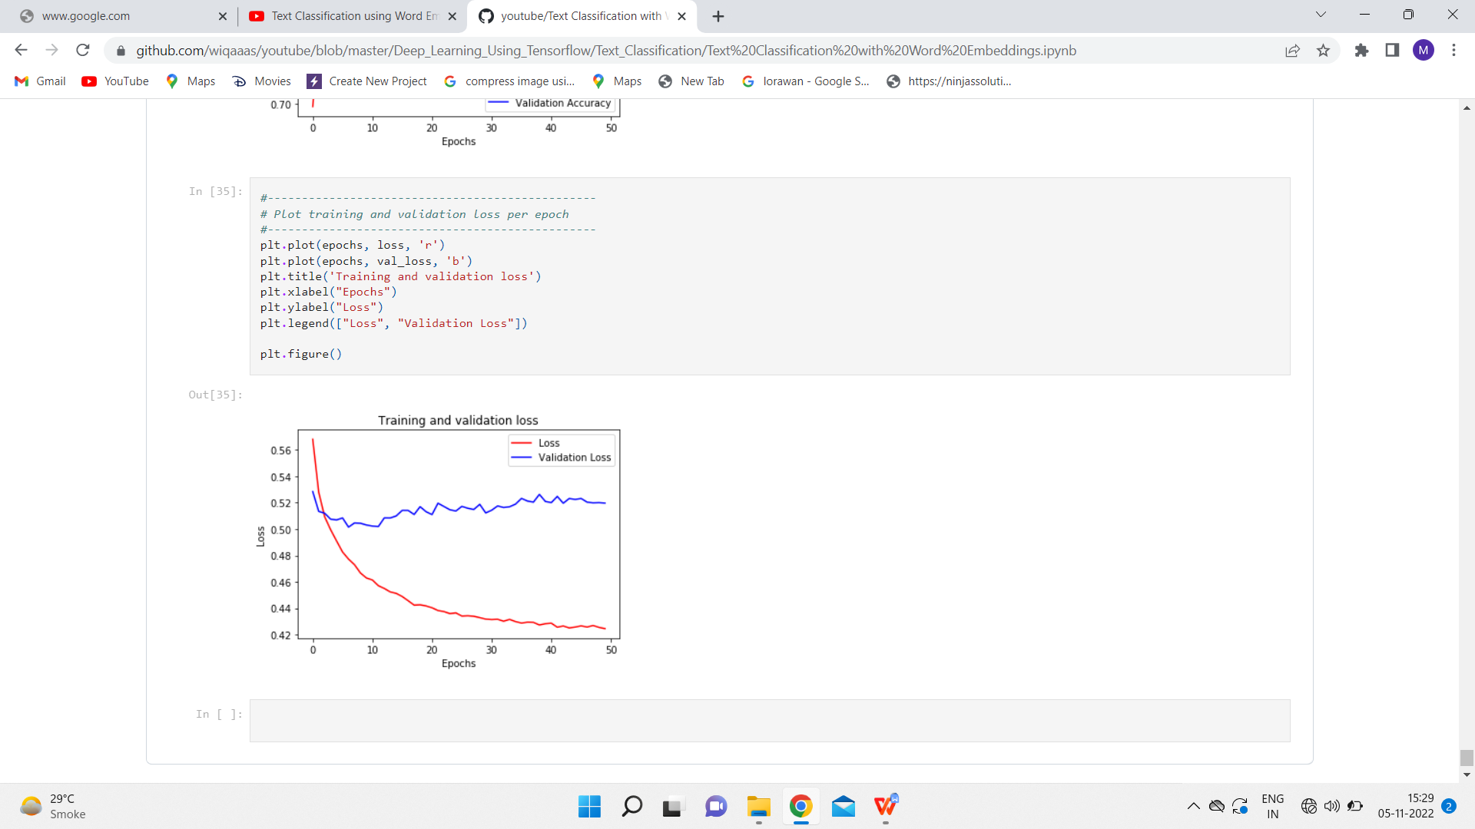

**RESULT**

The implementation was successful.

**Experiment 2**

**AIM**

To implement Neural Network Bigram Model.

**Software used**

Jupyter Notebook

**Dataset Used**

NLTK's Reuters corpus

**Theory**

The bigram model approximates the probability of a word given all the previous words by using only the conditional probability of one preceding word.

And so, when you use a bigram model to predict the conditional probability of the next word, you are thus making the following approximation:

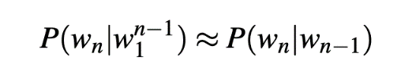

**Code**

|  |
| --- |
| # imports  import string  import random  import nltk  nltk.download('punkt')  nltk.download('stopwords')  nltk.download('reuters')  from nltk.corpus import reuters  from nltk import FreqDist    # input the reuters sentences  sents  =reuters.sents()    # write the removal characters such as : Stopwords and punctuation  stop_words = set(stopwords.words('english'))  string.punctuation = string.punctuation +'"'+'"'+'-'+'''+'''+'—'  string.punctuation  removal_list = list(stop_words) + list(string.punctuation)+ ['lt','rt']  removal_list    # generate unigrams bigrams trigrams  unigram=[]  bigram=[]  trigram=[]  tokenized_text=[]  for sentence in sents:    sentence = list(map(lambda x:x.lower(),sentence))    for word in sentence:          if word== '.':              sentence.remove(word)          else:              unigram.append(word)      tokenized_text.append(sentence)    bigram.extend(list(ngrams(sentence, 2,pad_left=True, pad_right=True)))    trigram.extend(list(ngrams(sentence, 3, pad_left=True, pad_right=True)))    # remove the n-grams with removable words  def remove_stopwords(x):      y = []      for pair in x:          count = 0          for word in pair:              if word in removal_list:                  count = count or 0              else:                  count = count or 1          if (count==1):              y.append(pair)      return (y)  unigram = remove_stopwords(unigram)  bigram = remove_stopwords(bigram)  trigram = remove_stopwords(trigram)    # generate frequency of n-grams  freq_bi = FreqDist(bigram)  freq_tri = FreqDist(trigram)    d = defaultdict(Counter)  for a, b, c in freq_tri:      if(a != None and b!= None and c!= None):        d[a, b] += freq_tri[a, b, c]      # Next word prediction  s=''  def pick_word(counter):      "Chooses a random element."      return random.choice(list(counter.elements()))  prefix = "he", "said"  print(" ".join(prefix))  s = " ".join(prefix)  for i in range(19):      suffix = pick_word(d[prefix])      s=s+' '+suffix      print(s)      prefix = prefix[1], suffix |

**OUTPUT**

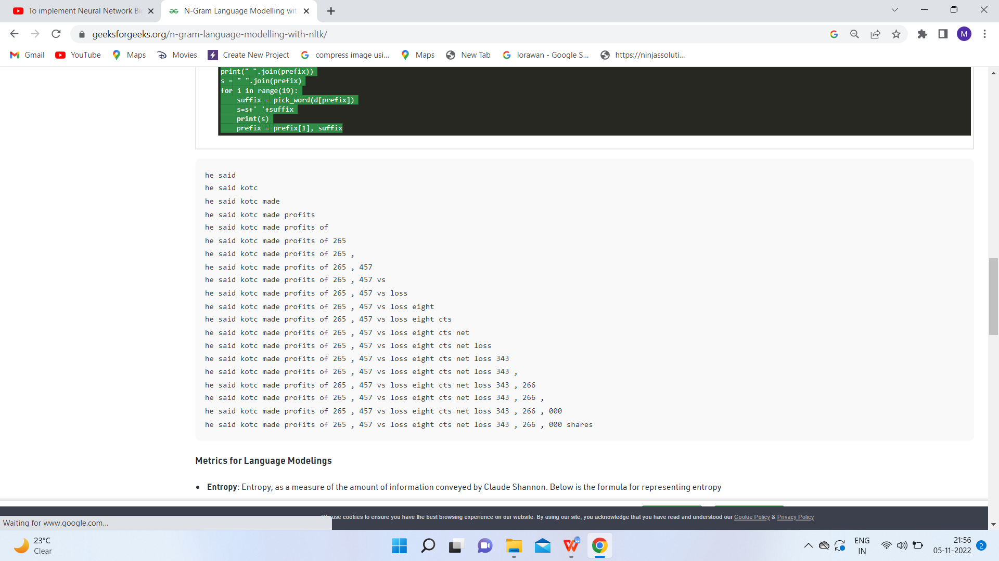

**RESULT**

The implementation was successful.

**Experiment 3**

**AIM**

Implementation of word2vec using NumPy.

**Software used**

Jupyter Notebook

**Dataset/Corpus Used**

|  |
| --- |
| corpus = [['this','mobile','is','good','not','affordable']] |

**Theory**

NumPy is a library for the Python programming language, adding support for large, multi-dimensional arrays and matrices, along with a large collection of high-level mathematical functions to operate on these arrays.

Word2Vec is a method to construct such an embedding. It can be obtained using two methods (both involving Neural Networks): Skip Gram and Common Bag Of Words (CBOW). word2vec is not a singular algorithm, rather, it is a family of model architectures and optimizations that can be used to learn word embedding’s from large datasets. Embeddings learned through word2vec have proven to be successful on a variety of downstream natural language processing tasks.

* ***Continuous bag-of-words model:*** predicts the middle word based on surrounding context words. The context consists of a few words before and after the current (middle) word. This architecture is called a bag-of-words model as the order of words in the context is not important.
* ***Continuous skip-gram model:*** predicts words within a certain range before and after the current word in the same sentence.

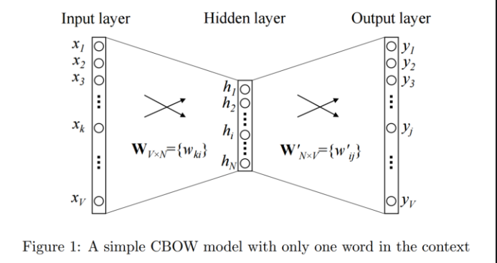

**Code**

|  |
| --- |
| import numpy as np  import pandas as pd  import re  from collections import defaultdict  class word2vec():  def _init_ (self):  self.n = settings['n']  self.eta = settings['learning_rate']  self.epochs = settings['epochs']  self.window = settings['window_size']  pass  # GENERATE TRAINING DATA  def generate_training_data(self, settings, corpus):  # GENERATE WORD COUNTS  word_counts = defaultdict(int)  for row in corpus:  for word in row:  word_counts[word] += 1  self.v_count = len(word_counts.keys())  # GENERATE LOOKUP DICTIONARIES  self.words_list = sorted(list(word_counts.keys()),reverse=False)  self.word_index = dict((word, i) for i, word in enumerate(self.words_list))  self.index_word = dict((i, word) for i, word in enumerate(self.words_list))  training_data = []  # CYCLE THROUGH EACH SENTENCE IN CORPUS  for sentence in corpus:  sent_len = len(sentence)  # CYCLE THROUGH EACH WORD IN SENTENCE  for i, word in enumerate(sentence):  #w_target = sentence[i]  w_target = self.word2onehot(sentence[i])  # CYCLE THROUGH CONTEXT WINDOW  w_context = []  for j in range(i-self.window, i+self.window+1):  if j!=i and j<=sent_len-1 and j>=0:  w_context.append(self.word2onehot(sentence[j]))  training_data.append([w_target, w_context])  return np.array(training_data)  # SOFTMAX ACTIVATION FUNCTION  def softmax(self, x):  e_x = np.exp(x - np.max(x))  return e_x / e_x.sum(axis=0)  # CONVERT WORD TO ONE HOT ENCODING  def word2onehot(self, word):  word_vec = [0 for i in range(0, self.v_count)]  word_index = self.word_index[word]  word_vec[word_index] = 1  return word_vec  # FORWARD PASS  def forward_pass(self, x):  h = np.dot(self.w1.T, x)  u = np.dot(self.w2.T, h)  y_c = self.softmax(u)  return y_c, h, u  # BACKPROPAGATION  def backprop(self, e, h, x):  dl_dw2 = np.outer(h, e)  dl_dw1 = np.outer(x, np.dot(self.w2, e.T))  # UPDATE WEIGHTS  self.w1 = self.w1 - (self.eta * dl_dw1)  self.w2 = self.w2 - (self.eta * dl_dw2)  pass  # TRAIN W2V model  def train(self, training_data):  # INITIALIZE WEIGHT MATRICES  self.w1 = np.random.uniform(-0.8, 0.8, (self.v_count, self.n)) # embedding matrix  self.w2 = np.random.uniform(-0.8, 0.8, (self.n, self.v_count)) # context matrix  # CYCLE THROUGH EACH EPOCH  for i in range(0, self.epochs):  self.loss = 0  # CYCLE THROUGH EACH TRAINING SAMPLE  for w_t, w_c in training_data:  # FORWARD PASS  y_pred, h, u = self.forward_pass(w_t)    # CALCULATE ERROR  EI = np.sum([np.subtract(y_pred, word) for word in w_c], axis=0)  # BACKPROPAGATION  self.backprop(EI, h, w_t)  # CALCULATE LOSS  self.loss += -np.sum([u[word.index(1)] for word in w_c]) + len(w_c) * np.log(np.sum(np.exp(u)))  #self.loss += -2*np.log(len(w_c)) -np.sum([u[word.index(1)] for word in w_c]) + (len(w_c) * np.log(np.sum(np.exp(u))))    print('EPOCH:',i, 'LOSS:', self.loss)  # input a word, returns a vector (if available)  def word_vec(self, word):  w_index = self.word_index[word]  v_w = self.w1[w_index]  return v_w  # input a vector, returns nearest word(s)  def vec_sim(self, vec, top_n):  # CYCLE THROUGH VOCAB  word_sim = {}  for i in range(self.v_count):  v_w2 = self.w1[i]  theta_num = np.dot(vec, v_w2)  theta_den = np.linalg.norm(vec) * np.linalg.norm(v_w2)  theta = theta_num / theta_den  word = self.index_word[i]  word_sim[word] = theta  words_sorted = sorted(word_sim.items(), key=lambda x: x[1], reverse=True)    for word, sim in words_sorted[:top_n]:  print(word, sim)  # input word, returns top [n] most similar words  def word_sim(self, word, top_n):    w1_index = self.word_index[word]  v_w1 = self.w1[w1_index]  # CYCLE THROUGH VOCAB  word_sim = {}  for i in range(self.v_count):  v_w2 = self.w1[i]  theta_num = np.dot(v_w1, v_w2)  theta_den = np.linalg.norm(v_w1) * np.linalg.norm(v_w2)  theta = theta_num / theta_den  word = self.index_word[i]  word_sim[word] = theta  words_sorted = sorted(word_sim.items(), key=lambda x: x[1], reverse=True)  for word, sim in words_sorted[:top_n]:  print(word, sim) |

**Example run and OUTPUT**

|  |
| --- |
| settings = {}  settings['n'] = 5 # dimension of word embeddings  settings['window_size'] = 2 # context window +/- center word  settings['min_count'] = 0 # minimum word count  settings['epochs'] = 600 # number of training epochs  settings['neg_samp'] = 10 # number of negative words to use during training  settings['learning_rate'] = 0.01 # learning rate  np.random.seed(0) # set the seed for reproducibility  corpus = [['this','mobile','is','good','not','affordable']]  # INITIALIZE W2V MODEL  w2v = word2vec()  # generate training data  training_data = w2v.generate_training_data(settings, corpus)  # train word2vec model  w2v.train(training_data) |



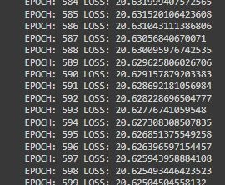

**RESULT**

The implementation was successful.

**Experiment 4**

**AIM**

Implementation of word2vec using tensorflow.

**Software used**

Jupyter Notebook

**Dataset/Corpus Used**

|  |
| --- |
| corpus_raw = 'this mobile is good this mobile is not good this mobile is affordable' |

**Theory**

Word2Vec is a method to construct such an embedding. It can be obtained using two methods (both involving Neural Networks): Skip Gram and Common Bag Of Words (CBOW). word2vec is not a singular algorithm, rather, it is a family of model architectures and optimizations that can be used to learn word embedding’s from large datasets. Embedding’s learned through word2vec have proven to be successful on a variety of downstream natural language processing tasks.

TensorFlow is a free and open-source software library for machine learning and artificial intelligence. It can be used across a range of tasks but has a particular focus on training and inference of deep neural networks.

**Code**

|  |
| --- |
| from _future_ import absolute_import, division, print_function, unicode_literals  import tensorflow as tf  import numpy as np  class Word2Vec:  def _init_(self, vocab_size=0, embedding_dim=16, optimizer='sgd', epochs=10000):  self.vocab_size=vocab_size  self.embedding_dim=5  self.epochs=epochs  if optimizer=='adam':  self.optimizer = tf.optimizers.Adam()  else:  self.optimizer = tf.optimizers.SGD(learning_rate=0.1)  def train(self, x_train=None, y_train=None):  self.W1 = tf.Variable(tf.random.normal([self.vocab_size, self.embedding_dim]))  self.b1 = tf.Variable(tf.random.normal([self.embedding_dim])) #bias  self.W2 = tf.Variable(tf.random.normal([self.embedding_dim, self.vocab_size]))  self.b2 = tf.Variable(tf.random.normal([self.vocab_size]))  for _ in range(self.epochs):  with tf.GradientTape() as t:  hidden_layer = tf.add(tf.matmul(x_train,self.W1),self.b1)  output_layer = tf.nn.softmax(tf.add( tf.matmul(hidden_layer, self.W2), self.b2))  cross_entropy_loss = tf.reduce_mean(-tf.math.reduce_sum(y_train * tf.math.log(output_layer), axis=[1]))  grads = t.gradient(cross_entropy_loss, [self.W1, self.b1, self.W2, self.b2])  self.optimizer.apply_gradients(zip(grads,[self.W1, self.b1, self.W2, self.b2]))  if(_ % 1000 == 0):  print(cross_entropy_loss)  def vectorized(self, word_idx):  return (self.W1+self.b1)[word_idx]  corpus_raw = 'this mobile is good this mobile is not good this mobile is affordable'  # convert to lower case  corpus_raw = corpus_raw.lower()  # raw sentences is a list of sentences.  raw_sentences = corpus_raw.split('.')  sentences = []  for sentence in raw_sentences:  sentences.append(sentence.split())    data = []  WINDOW_SIZE = 2  for sentence in sentences:  for word_index, word in enumerate(sentence):  for nb_word in sentence[max(word_index - WINDOW_SIZE, 0) : min(word_index + WINDOW_SIZE, len(sentence)) + 1] :  if nb_word != word:  data.append([word, nb_word])    words = []  for word in corpus_raw.split():  if word != '.': # because we don't want to treat . as a word  words.append(word)  words = set(words) # so that all duplicate words are removed  word2int = {}  int2word = {}  vocab_size = len(words) # gives the total number of unique words  for i,word in enumerate(words):  word2int[word] = i  int2word[i] = word    # function to convert numbers to one hot vectors  def to_one_hot(data_point_index, vocab_size):  temp = np.zeros(vocab_size)  temp[data_point_index] = 1  return temp  x_train = [] # input word  y_train = [] # output word  for data_word in data:  x_train.append(to_one_hot(word2int[ data_word[0] ], vocab_size))  y_train.append(to_one_hot(word2int[ data_word[1] ], vocab_size))  # convert them to numpy arrays  x_train = np.asarray(x_train, dtype='float32')  y_train = np.asarray(y_train, dtype='float32')  w2v = Word2Vec(vocab_size=vocab_size, optimizer='adam', epochs=10000)  w2v.train(x_train, y_train)  w2v.vectorized(word2int['mobile'])  sentences = sentences[0]  vectors = []  for i in sentences:  vectors.append(w2v.vectorized(word2int[i]))  from sklearn.manifold import TSNE  from sklearn import preprocessing  model = TSNE(n_components=2, random_state=0)  np.set_printoptions(suppress=True)  vectors = model.fit_transform(vectors)  normalizer = preprocessing.Normalizer()  vectors = normalizer.fit_transform(vectors, 'l2')  import matplotlib.pyplot as plt  fig, ax = plt.subplots()  ax.set_xlim(left=-1, right=1)  ax.set_ylim(bottom=-1, top=1)  for word in words:  print(word, vectors[word2int[word]][1])  ax.annotate(word, (vectors[word2int[word]][0],vectors[word2int[word]][1] ))  plt.show() |

**OUTPUT**

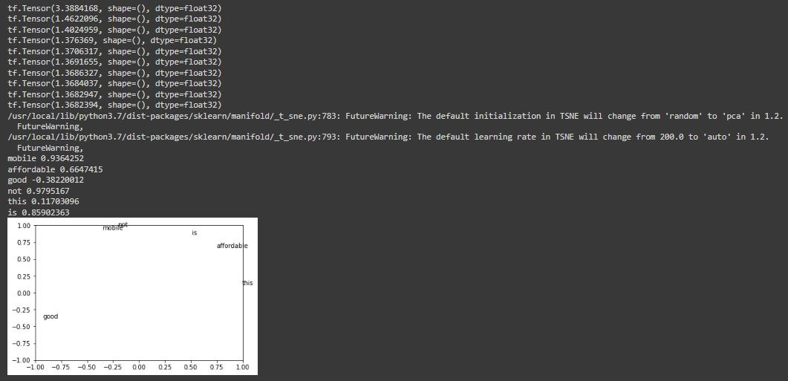

**RESULT**

The implementation was successful.

**Experiment 5**

**AIM**

To implement GLOVE using numpy gradient descent.

**Software used**

Jupyter Notebook

**Dataset/Corpus Used**

Genism Data – “text8”

**Theory**

GloVe is a word vector technique that rode the wave of word vectors after a brief silence. Just to refresh, word vectors put words to a nice vector space, where similar words cluster together and different words repel. The advantage of GloVe is that, unlike Word2vec, GloVe does not rely just on local statistics (local context information of words) but incorporates global statistics (word co-occurrence) to obtain word vectors.

**Code**

|  |
| --- |
| import gensim.downloader as api  dataset = api.load("text8")  import itertools  corpus = list(itertools.chain.from_iterable(dataset)) |

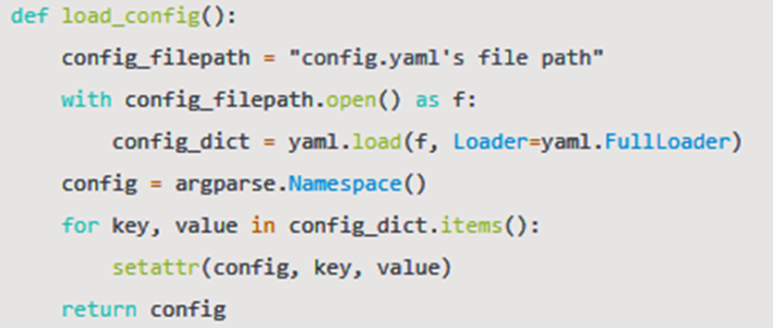

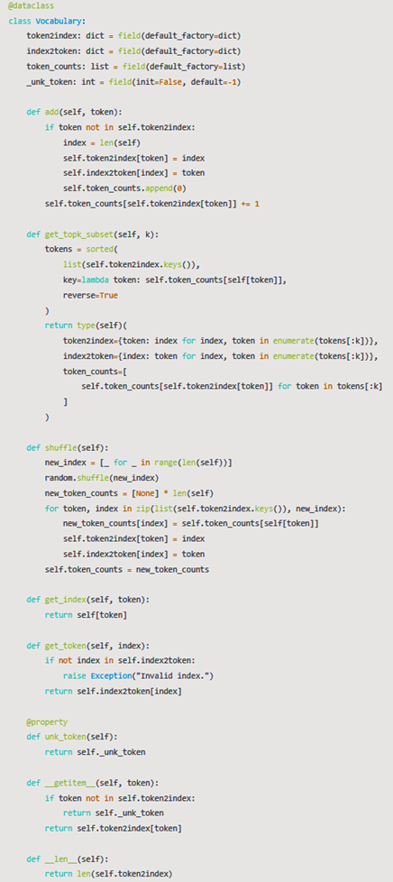



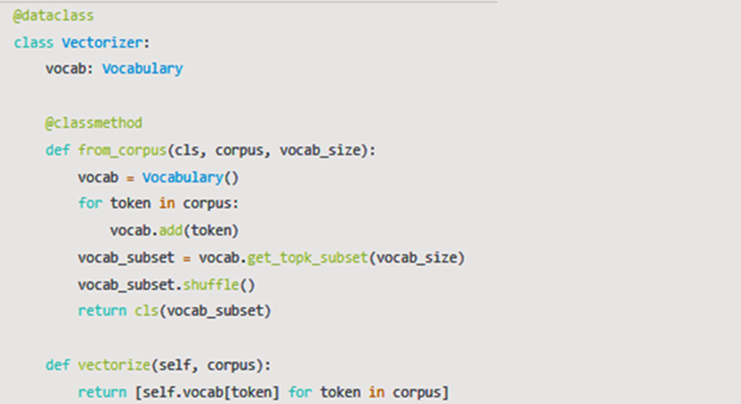

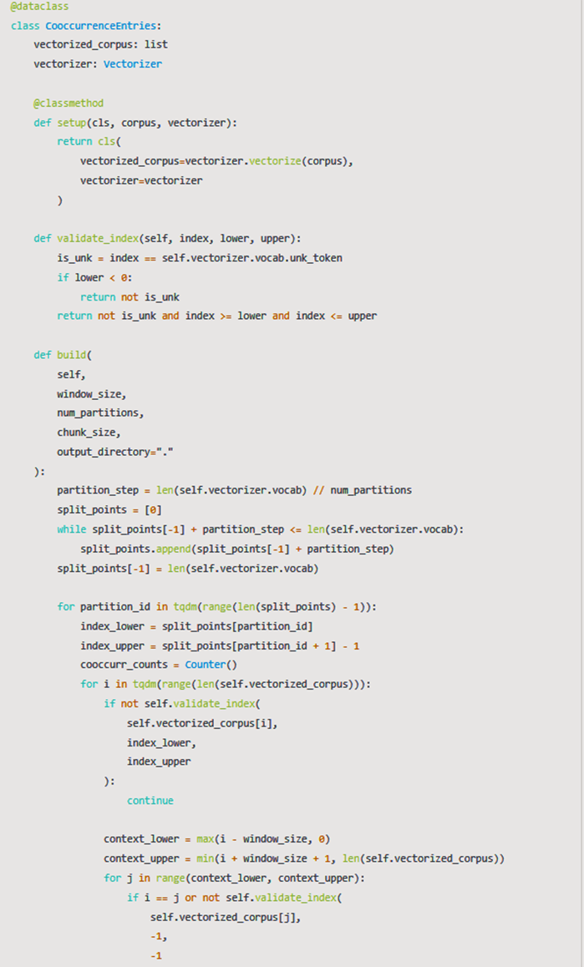

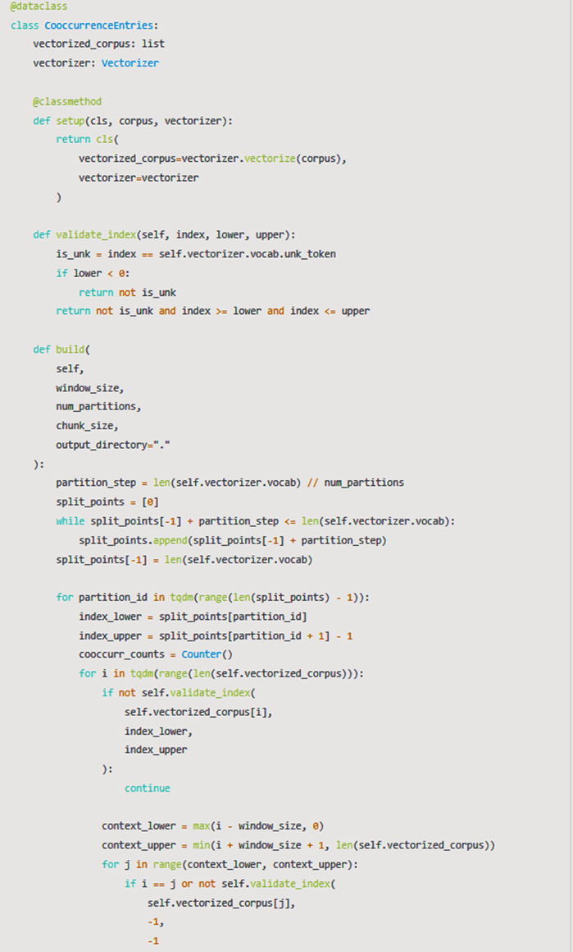

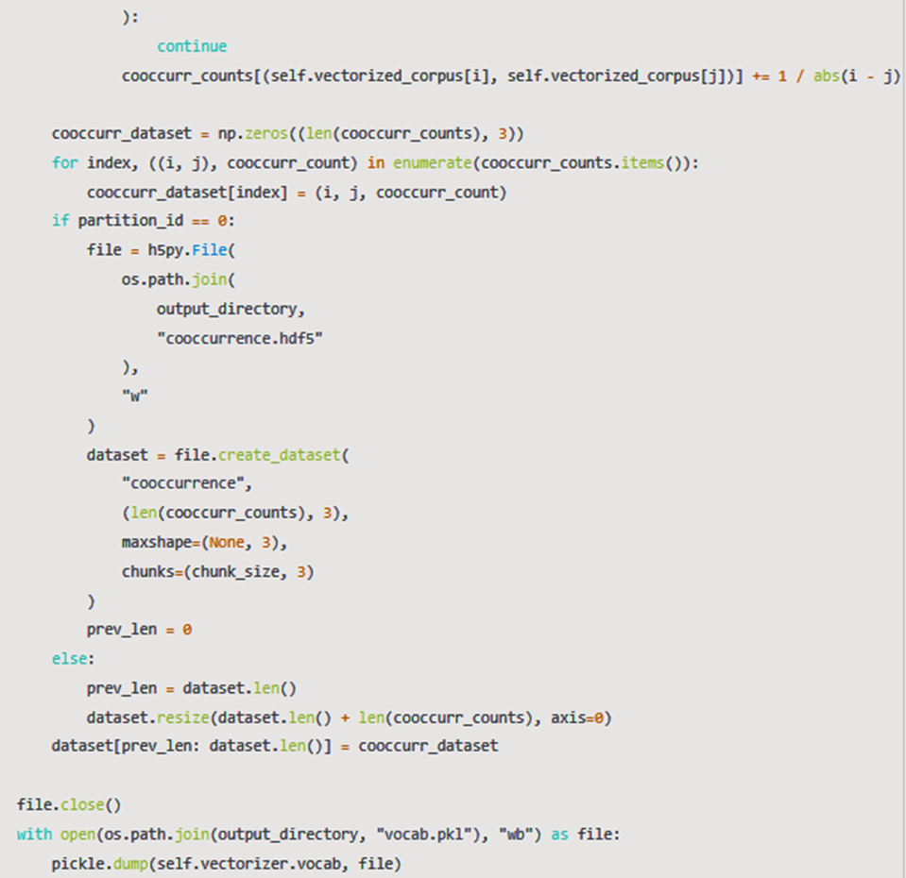



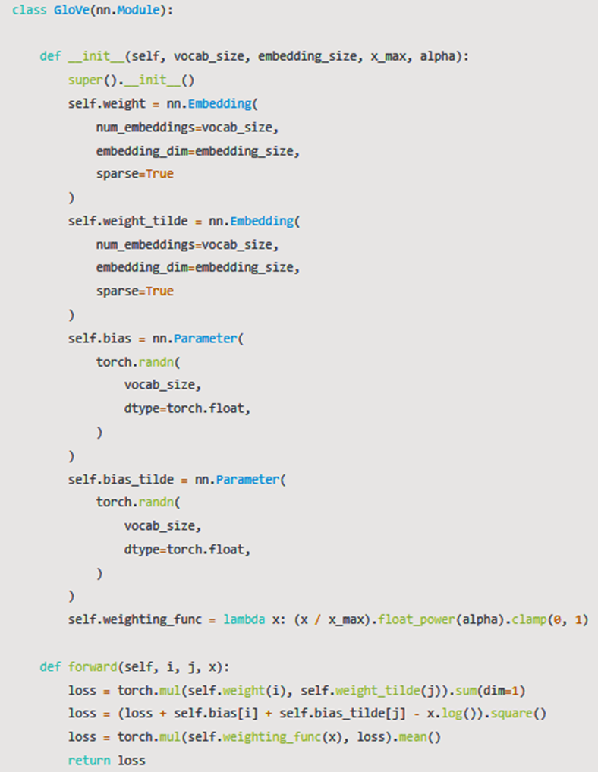

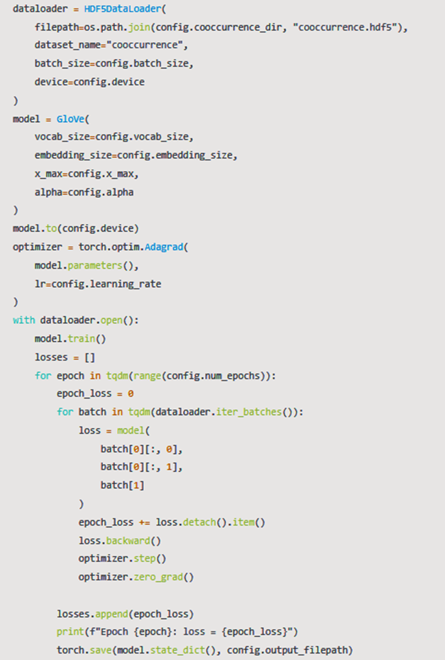



**OUTPUT**

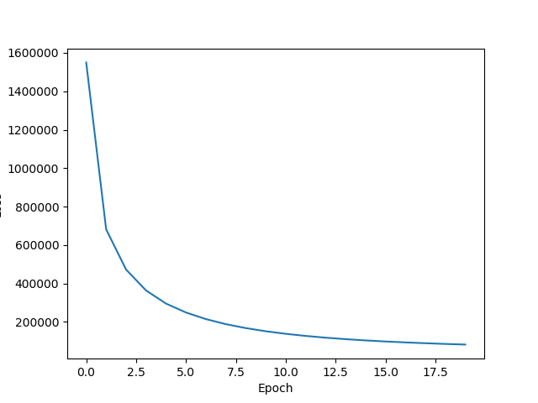

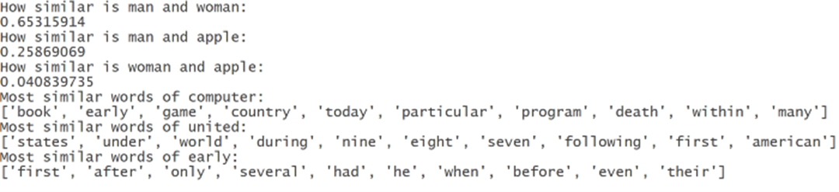

**RESULT**

The implementation was successful.

**Experiment 6**

**AIM**

To implement GLOVE using Alternative Least Squares.

**Software used**

Jupyter Notebook

**Dataset/Corpus Used**

Kaggle Retail Rocket recommender system dataset – events.csv

**Theory**

Alternating Least Square (ALS) is also a matrix factorization algorithm and it runs itself in a parallel fashion. ALS is implemented in Apache Spark ML and built for a larges-scale collaborative filtering problems. ALS is doing a pretty good job at solving scalability and sparseness of the Ratings data, and it’s simple and scales well to very large datasets.

**Code**

|  |
| --- |
| !pip install implicit  #import libraries  import sys  import pandas as pd  import numpy as np  import scipy.sparse as sparse  from scipy.sparse.linalg import spsolve  import random  from sklearn.preprocessing import MinMaxScaler  import implicit  from datetime import datetime, timedelta  #Data Preprocessing  def create_data(datapath,start_date,end_date):      df=pd.read_csv(datapath)      df=df.assign(date=pd.Series(datetime.fromtimestamp(a/1000).date() for a in df.timestamp))      df=df.sort_values(by='date').reset_index(drop=True) # for some reasons RetailRocket did NOT sort data by date      df=df[(df.date>=datetime.strptime(start_date,'%Y-%m-%d').date())&(df.date<=datetime.strptime(end_date,'%Y-%m-%d').date())]      df=df[['visitorid','itemid','event']]      return df  #Download the kaggle RetailRocket data and give the events.csv file path  datapath= '/content/drive/MyDrive/dataset/events.csv'  data=create_data(datapath,'2015-5-3','2015-5-18')  data['visitorid'] = data['visitorid'].astype("category")  data['itemid'] = data['itemid'].astype("category")  data['visitor_id'] = data['visitorid'].cat.codes  data['item_id'] = data['itemid'].cat.codes  data['event']=data['event'].astype('category')  data['event']=data['event'].cat.codes  sparse_item_user = sparse.csr_matrix((data['event'].astype(float), (data['item_id'], data['visitor_id'])))  sparse_user_item = sparse.csr_matrix((data['event'].astype(float), (data['visitor_id'], data['item_id'])))  #Building the model  model = implicit.als.AlternatingLeastSquares(factors=20, regularization=0.1, iterations=20)  alpha_val = 40  data_conf = (sparse_item_user * alpha_val).astype('double')  model.fit(data_conf)  ###USING THE MODEL  #Get Recommendations  user_id =   14  recommended = model.recommend(user_id, sparse_user_item[user_id])  recommended = pd.DataFrame(recommended)  recommended = recommended.T  recommended.columns = ['items', 'scores']  print(recommended)  #Get similar items  item_id = 7  n_similar = 4  similar = model.similar_items(item_id, n_similar)  similar = pd.DataFrame(similar)  similar = similar.T  similar.columns = ['items', 'scores']  print(similar) |

**OUTPUT**

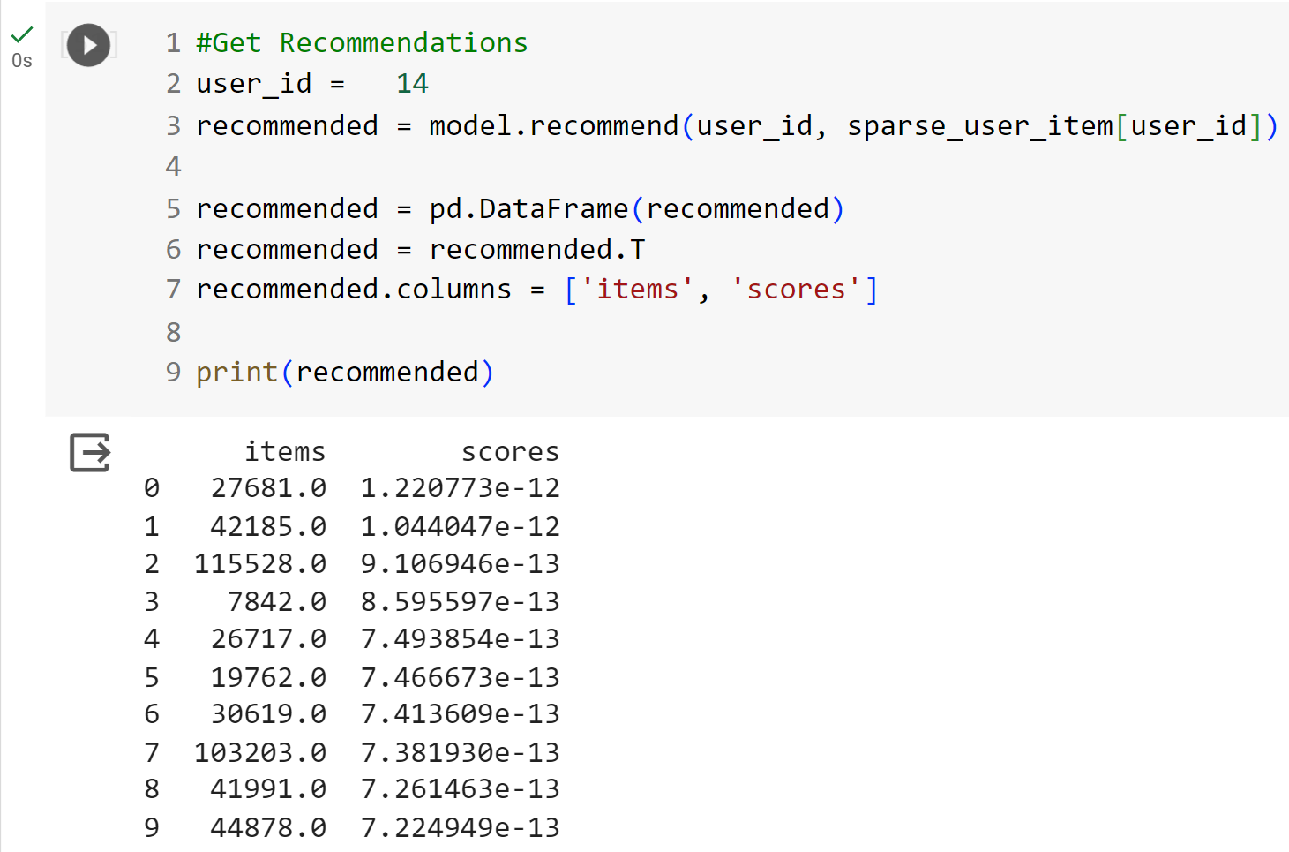

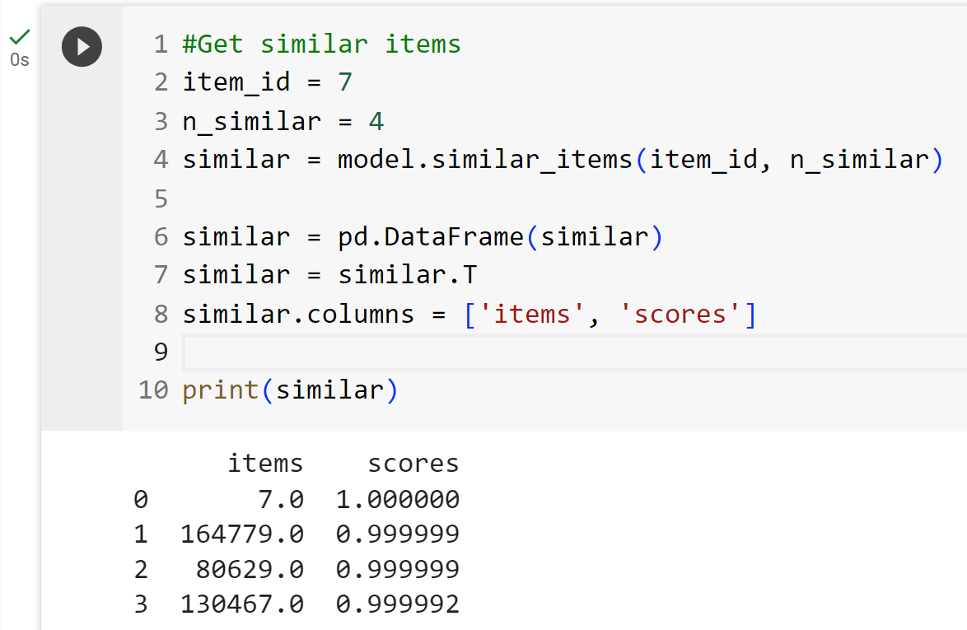

**RESULT**

The implementation was successful.

**Experiment 7**

**AIM**

Visualizing data with analogies with t-SNE.

**Software used**

Jupyter Notebook

**Dataset/Corpus Used**

MNIST iris dataset

**Theory**

t-Distributed Stochastic Neighbor Embedding (t-SNE) is an unsupervised, non-linear technique primarily used for data exploration and visualizing high-dimensional data. In simpler terms, t-SNE gives you a feel or intuition of how the data is arranged in a high-dimensional space.

t-SNE is a tool to visualize high-dimensional data. It converts similarities between data points to joint probabilities and tries to minimize the Kullback-Leibler divergence between the joint probabilities of the low-dimensional embedding and the high-dimensional data. t-SNE has a cost function that is not convex, i.e. with different initializations we can get different results.

It is highly recommended to use another dimensionality reduction method (e.g. PCA for dense data or TruncatedSVD for sparse data) to reduce the number of dimensions to a reasonable amount (e.g. 50) if the number of features is very high. This will suppress some noise and speed up the computation of pairwise distances between samples.

**Code**

|  |
| --- |
| from sklearn.manifold import TSNE  from keras.datasets import mnist  from sklearn.datasets import load_iris  from numpy import reshape  import seaborn as sns  import pandas as pd  iris = load_iris()  x = iris.data  y = iris.target  tsne = TSNE(n_components=2, verbose=1, random_state=123)  z = tsne.fit_transform(x)  df = pd.DataFrame()  df["y"] = y  df["comp-1"] = z[:,0]  df["comp-2"] = z[:,1]  sns.scatterplot(x="comp-1", y="comp-2", hue=df.y.tolist(),  palette=sns.color_palette("hls", 3),  data=df).set(title="Iris data T-SNE projection")  (x_train, y_train), (_ , _) = mnist.load_data()  x_train = x_train[:3000]  y_train = y_train[:3000]  print(x_train.shape)    x_mnist = reshape(x_train, [x_train.shape[0], x_train.shape[1]*x_train.shape[2]])  print(x_mnist.shape)  tsne = TSNE(n_components=2, verbose=1, random_state=123)  z = tsne.fit_transform(x_mnist)    df = pd.DataFrame()  df["y"] = y_train  df["comp-1"] = z[:,0]  df["comp-2"] = z[:,1]  sns.scatterplot(x="comp-1", y="comp-2", hue=df.y.tolist(),  palette=sns.color_palette("hls", 10),  data=df).set(title="MNIST data T-SNE projection") |

**OUTPUT**

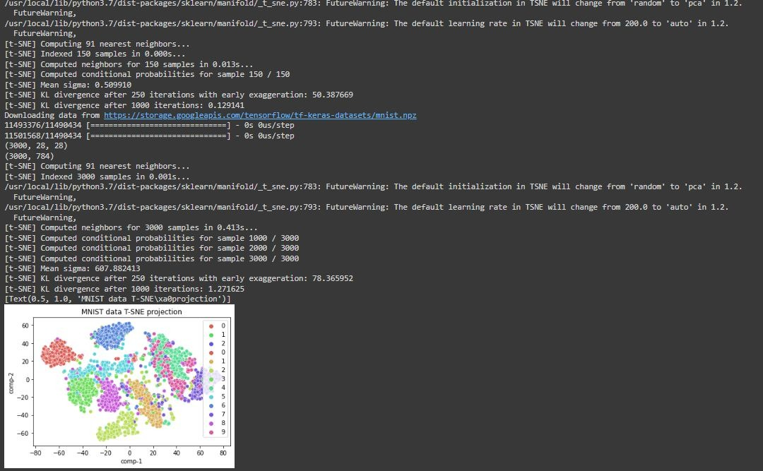

**RESULT**

The implementation was successful.

**Experiment 8**

**AIM**

Visualizing data with analogies with PCA.

**Software used**

Jupyter Notebook

**Dataset Used**

Car price dataset

**Theory**

Principal Component analysis is a technique for feature extraction — so it combines our input variables in a specific way, then we can drop the “least important” variables while still retaining the most valuable parts of all of the variables! As an added benefit, each of the “new” variables after PCA are all independent of one another. This is a benefit because the assumptions of a linear model require our independent variables to be independent of one another. If we decide to fit a linear regression model with these “new” variables, this assumption will necessarily be satisfied.

**Code**

|  |
| --- |
| import pandas as pd  import numpy as np  import seaborn as sb  from sklearn import preprocessing  import matplotlib.pyplot as plt  from sklearn.model_selection import train_test_split  from sklearn.linear_model import LinearRegression  from sklearn.metrics import r2_score  df = pd.read_csv("/content/CarPrice_1.csv", encoding = 'unicode_escape')  print(df)  label_encoder = preprocessing.LabelEncoder()  cols_tbe = ['CarName', 'fueltype', 'aspiration', 'doornumber', 'carbody', 'drivewheel', 'enginelocation', 'fuelsystem', 'enginetype', 'cylindernumber']  for col_tbe in cols_tbe:  df[col_tbe] = df[col_tbe].astype('|S')  df[col_tbe] = label_encoder.fit_transform(df[col_tbe])  X = df.iloc[:,0:-1].values  y = df.iloc[:,-1].values  X_std = preprocessing.StandardScaler().fit_transform(X)  cov_m = np.cov(X_std, rowvar=False)  cov_m = np.cov(X_std.T)  eig_vals, eig_vecs = np.linalg.eig(cov_m)  eig_pairs = [(np.abs(eig_vals[i]), eig_vecs[:,i]) for i in range(len(eig_vals))]  eig_pairs.sort()  eig_pairs.reverse()  tot = sum(eig_vals)  var_exp = [(i / tot)*100 for i in sorted(eig_vals, reverse=True)]  cum_var_exp = np.cumsum(var_exp)  matrix_w = np.hstack((eig_pairs[0][1].reshape(25,1),  eig_pairs[1][1].reshape(25,1),  eig_pairs[2][1].reshape(25,1),  eig_pairs[3][1].reshape(25,1),  eig_pairs[4][1].reshape(25,1),  eig_pairs[5][1].reshape(25,1),  eig_pairs[6][1].reshape(25,1),  eig_pairs[7][1].reshape(25,1),  eig_pairs[8][1].reshape(25,1),  eig_pairs[9][1].reshape(25,1),  eig_pairs[10][1].reshape(25,1),  eig_pairs[11][1].reshape(25,1),  eig_pairs[12][1].reshape(25,1),  eig_pairs[13][1].reshape(25,1),  eig_pairs[14][1].reshape(25,1)))  Y = X_std.dot(matrix_w)  principalDf = pd.DataFrame(data = Y, columns = ['PC1', 'PC2', 'PC3', 'PC4', 'PC5', 'PC6', 'PC7', 'PC8', 'PC9', 'PC10', 'PC11', 'PC12', 'PC13', 'PC14', 'PC15'])  final_df = pd.concat([principalDf, pd.DataFrame(y, columns=['price'])], axis = 1)  print(final_df)  data = final_df.values  X,y = data[:,:-1], data[:,-1]  X_train, X_test, y_train, y_test = train_test_split(X, y, test_size = 0.3, random_state = 0)  regr = LinearRegression()  regr.fit(X_train, y_train)  y_pred = regr.predict(X_test)  print('R2 Score:',r2_score(y_test, y_pred))  fig = plt.figure()  m, b = np.polyfit(y_test, y_pred, 1)  plt.plot(y_test, m*y_test + b, color='red')  plt.scatter(y_test, y_pred, alpha=.5)  fig.suptitle('Actual vs Predicted Price', fontsize = 20)  plt.xlabel('Actual', fontsize = 18)  plt.ylabel('Predicted', fontsize = 18)  plt.show()  data = df.values  X,y = data[:,:-1], data[:,-1]  X_train, X_test, y_train, y_test = train_test_split(X, y, test_size = 0.3, random_state = 0)  regr = LinearRegression()  regr.fit(X_train, y_train)  y_pred = regr.predict(X_test)  print('R2 Score (without using PCA):',r2_score(y_test, y_pred)) |

**OUTPUT**

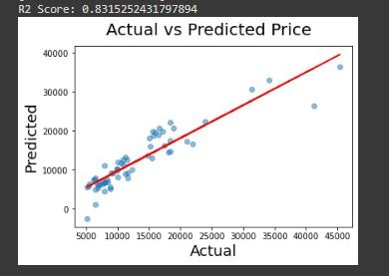



**RESULT**

The implementation was successful.

**Experiment 9**

**AIM**

To visualize the data analogies using embedding projectors.

**Software used**

Jupyter Notebook

**Dataset Used**

IMDB reviews dataset – subwords8k

**Theory**

The TensorBoard embedding projector is a very powerful tool in data analysis, specifically for interpreting and visualizing low-dimensional embeddings. In order to do so, first, it applies a dimensionality reduction algorithm to the input embeddings, between UMAP, T-SNE, PCA, or a custom one, to reduce their dimension to three and be able to render them in a three-dimensional space. Once the map is generated, this tool can be used, for example, to search for specific keywords associated with the embedding’s or highlight similar points in space. Ultimately, its goal is to provide a way to better interpret the embedding’s that our machine learning model is generating, to check if the similar ones according to our definition are plotted nearby in the 3D space.

**Code**

|  |
| --- |
| try:  # %tensorflow_version only exists in Colab.  %tensorflow_version 2.x  except Exception:  pass  %load_ext tensorboard  import os  import tensorflow as tf  import tensorflow_datasets as tfds  from tensorboard.plugins import projector  (train_data, test_data), info = tfds.load(  "imdb_reviews/subwords8k",  split=(tfds.Split.TRAIN, tfds.Split.TEST),  with_info=True,  as_supervised=True,  )  encoder = info.features["text"].encoder  # Shuffle and pad the data.  train_batches = train_data.shuffle(1000).padded_batch(  10, padded_shapes=((None,), ())  )  test_batches = test_data.shuffle(1000).padded_batch(  10, padded_shapes=((None,), ())  )  train_batch, train_labels = next(iter(train_batches))  # Create an embedding layer.  embedding_dim = 16  embedding = tf.keras.layers.Embedding(encoder.vocab_size, embedding_dim)  # Configure the embedding layer as part of a keras model.  model = tf.keras.Sequential(  [  embedding, # The embedding layer should be the first layer in a model.  tf.keras.layers.GlobalAveragePooling1D(),  tf.keras.layers.Dense(16, activation="relu"),  tf.keras.layers.Dense(1),  ]  )  # Compile model.  model.compile(  optimizer="adam",  loss=tf.keras.losses.BinaryCrossentropy(from_logits=True),  metrics=["accuracy"],  )  # Train model for one epoch.  history = model.fit(  train_batches, epochs=1, validation_data=test_batches, validation_steps=20  )  # Set up a logs directory, so Tensorboard knows where to look for files.  log_dir='/logs/imdb-example/'  if not os.path.exists(log_dir):  os.makedirs(log_dir)  # Save Labels separately on a line-by-line manner.  with open(os.path.join(log_dir, 'metadata.tsv'), "w") as f:  for subwords in encoder.subwords:  f.write("{}\n".format(subwords))  # Fill in the rest of the labels with "unknown".  for unknown in range(1, encoder.vocab_size - len(encoder.subwords)):  f.write("unknown #{}\n".format(unknown))  # Save the weights we want to analyze as a variable. Note that the first  # value represents any unknown word, which is not in the metadata, here  # we will remove this value.  weights = tf.Variable(model.layers[0].get_weights()[0][1:])  # Create a checkpoint from embedding, the filename and key are the  # name of the tensor.  checkpoint = tf.train.Checkpoint(embedding=weights)  checkpoint.save(os.path.join(log_dir, "embedding.ckpt"))  # Set up config.  config = projector.ProjectorConfig()  embedding = config.embeddings.add()  # The name of the tensor will be suffixed by `/.ATTRIBUTES/VARIABLE_VALUE`.  embedding.tensor_name = "embedding/.ATTRIBUTES/VARIABLE_VALUE"  embedding.metadata_path = 'metadata.tsv'  projector.visualize_embeddings(log_dir, config)  # Now run tensorboard against on log data we just saved.  %tensorboard --logdir /logs/imdb-example/ |

**OUTPUT**

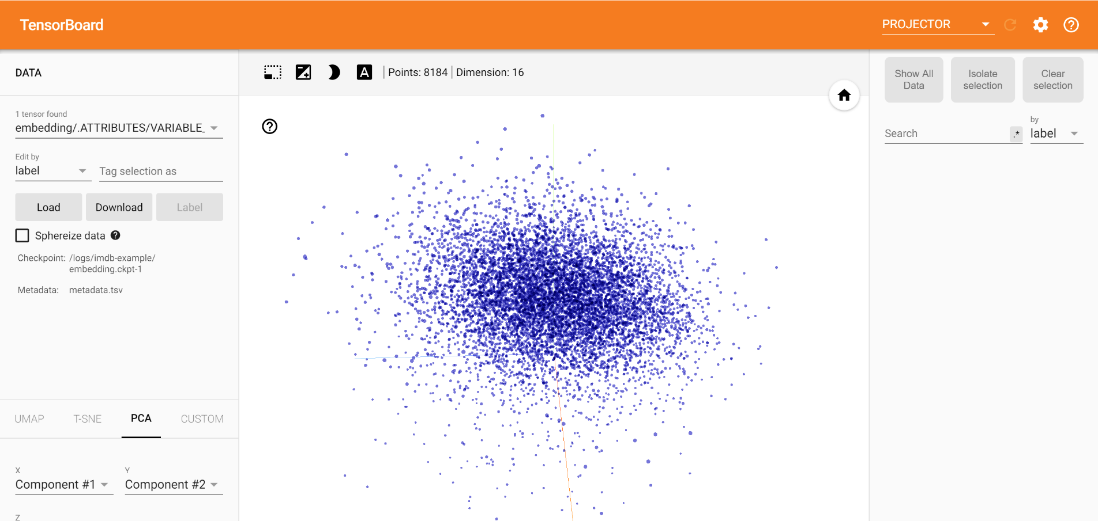

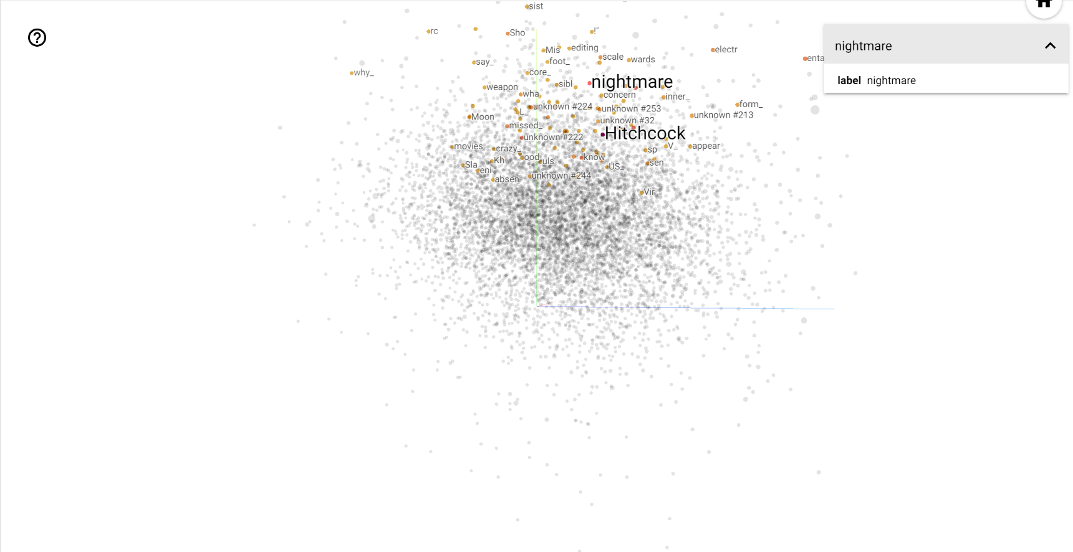

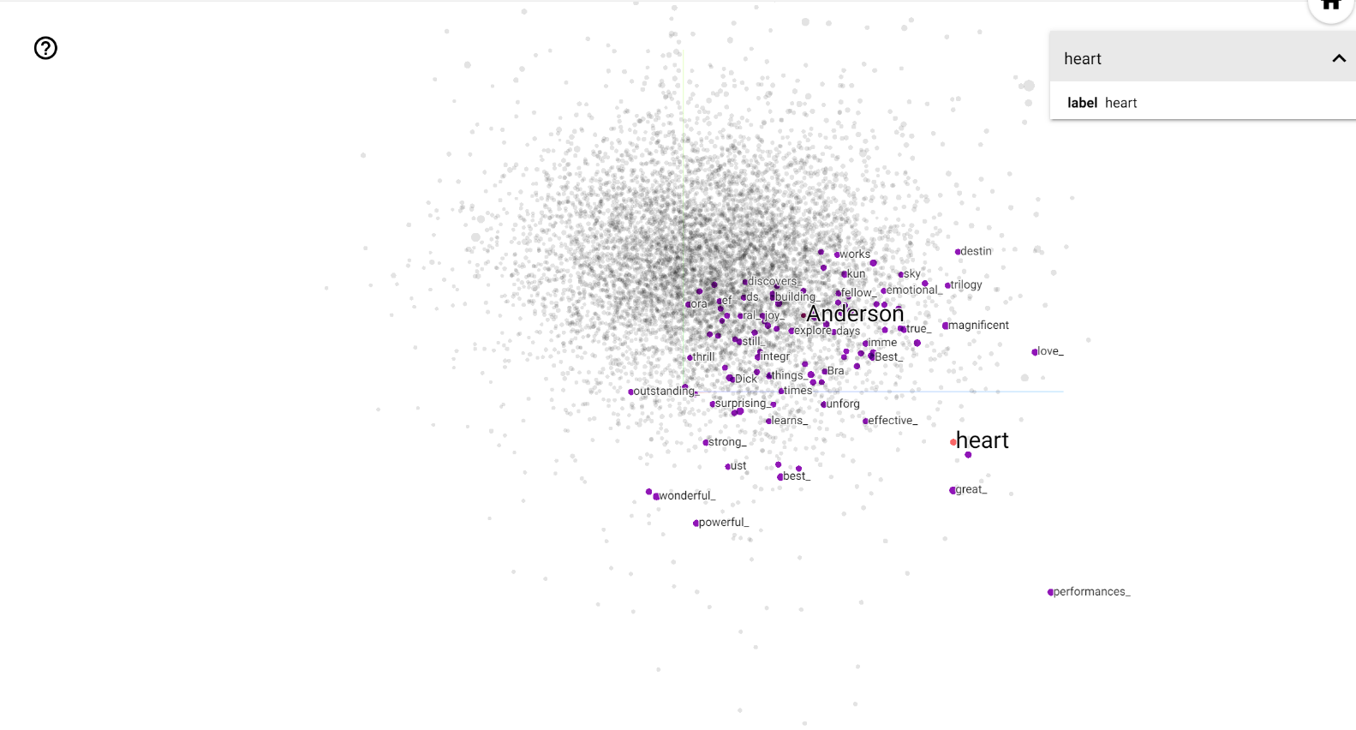

**RESULT**

The implementation was successful.

**Experiment 10**

**AIM**

To perform point wise Mutual Information.

**Software used**

Jupyter Notebook

**Dataset/Corpus Used**

|  |
| --- |
| s1="The world knows it has lost a heroic champion of justice and freedom"  s2="The earth recognizes the loss of a valliant champoin of independence and justice" |

**Theory**

In statistics, probability theory and information theory, pointwise mutual information (PMI), or point mutual information, is a measure of association. It compares the probability of two events occurring together to what this probability would be if the events were independent.

PMI (especially in its positive pointwise mutual information variant) has been described as "one of the most important concepts in NLP", where it "draws on the intuition that the best way to weigh the association between two words is to ask how much more the two words co-occur in a corpus than we would have a priori expected them to appear by chance.

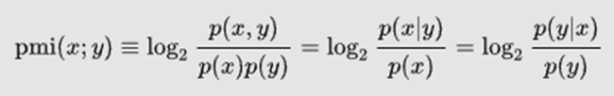

**Code and OUTPUT**

|  |
| --- |
| s1="The world knows it has lost a heroic champion of justice and freedom"  s2="The earth recognizes the loss of a valliant champoin of independence and justice"  from Cleaner import clean  #Removing punctuations, stopwords and storing important words in a list  sent1=clean(s1)  sent2=clean(s2) |



|  |
| --- |
| m=len(sent1)  n=len(sent2)  from Auxiliary import Commonwords, DisplayMatrixform  #Getting the list of common words and the removal of those words from the original list  common,s1,s2=Commonwords(sent1,sent2) |

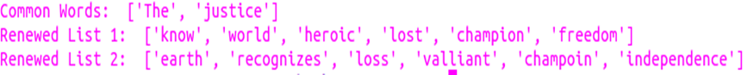

|  |
| --- |
| synmat={}if len(s2)<len(s1):  for i in s2:  synmat[i]={}  for j in s1:  synmat[i][j]=SyntacticSimilarity(i,j)else:  for i in s1:  synmat[i]={}  for j in s2:  synmat[i][j]=SyntacticSimilarity(i,j) |

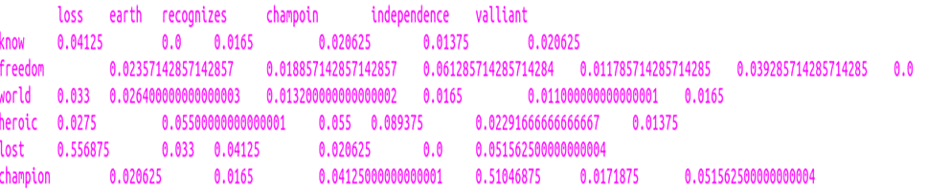

|  |
| --- |
| if len(s2)<len(s1):  for i in s2:  semmat[i]={}  for j in s1:  semmat[i][j]=SemanticSimilarity(i,j,a,delta,gamma)else:  for i in s1:  semmat[i]={}  for j in s2:  semmat[i][j]=SemanticSimilarity(i,j,a,delta,gamma) |

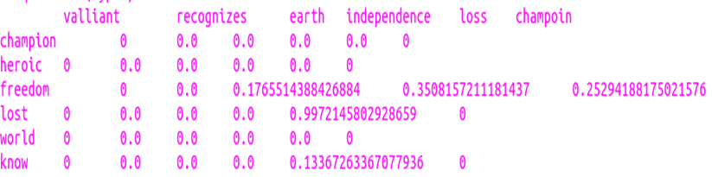



|  |
| --- |
| sentencesimilarity= (len(common)+rhosum)*(m+n)/(2*m*n)  print(sentencesimilarity) |



|  |
| --- |
| #Lemmatizing words and adding to the final array if they are not stopwordsfor w in words:  if w not in stop_words:  w=lemmatizer.lemmatize(w)  filtered_text.append(w) |

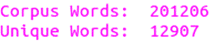

|  |
| --- |
| typefr=collections.Counter()  for w in filtered_text:  typefr[w]+=1  neighboursw1=collections.Counter()  n2w1=[]  for i in range(len(filtered_text)):  if w1==filtered_text[i]:  neighboursw1[filtered_text[i]]+=1  for j in range(0,a+1):  neighboursw1[filtered_text[i+j]]+=1  neighboursw1[filtered_text[i-j]]+=1  pmiw1={}  for t in neighboursw1.keys():  pmiw1[t]= math.log(neighboursw1[t]*m/(typefr[t]*typefr[w1]),2)pmiw1_sorted = sorted(pmiw1, key=pmiw1.get, reverse=True)  b1= math.floor((math.pow(math.log10(typefr[w1]),2)* math.log(len(unique),2))/delta)  for i in range(0,b1):  for j in range(0,b2):  if pmiw1_sorted[i]==pmiw2_sorted[j]:  betasumw1+=math.pow(pmiw2[pmiw1_sorted[i]],gamma)  similarity= betasumw1/b1 + betasumw2/b2  target=open("Lambda.txt","r")  lmbda=float(target.read())  target.close()  similarity,lmbda= normalized_similarity(similarity,lmbda)  target=open("Lambda.txt","w")  target.write(str(lmbda))  target.close()  return similarity  #Returning Normalized Similaritydef normalized_similarity(similarity,lmbda):  if similarity>lmbda:  lmbda=math.ceil(similarity)  similarity/=lmbda  return similarity,lmbda |

|  |  |
| --- | --- |
|  |  |

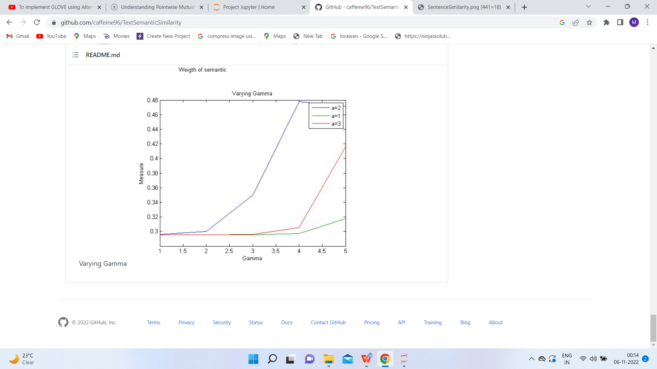

**RESULT**

The implementation was successful.